Database Systems Development

Using Oracle® Forms

By
Sarfraz Ahmad

Abstract

This is the report for assignment one for the course Database Systems Development (CIFM06) taught under MSc Information System engineering degree February 2008/2009. The report describes the techniques for modeling the “As is” system for the given Bank case study. Assignment has been divided into five sections; section one models the class diagram along with set of tables and appropriate attributes, with sample data. The second section of the report relates implementation of case study using Oracle Forms and Triggers to develop a set of transactions based on the proposed system design considering the general and technical software development issues. For the design of system MagicDraw UML 11.0 was utilized to design Database Schema. The third section of the report evaluates the developed system with ISO evaluation parameters. Finally, the report concludes what quality attributes have been fulfilled in the development of the Battle Town’s Bank system and strives to highlight the areas that particularly need to be improved for a successful competitor in the presence of Internet technology.

Table of Contents

Abstract i
Table of Contents ii
Task1 1
Database Design 1
1.Class Diagram 1
Test Plan 16
Appendix C - Running the Developed System 39

Task1

Database Design
This section of the report aims to show the proficiency in the use data modeling techniques using Class diagram to design “As Is” model for the given case study named Bank Database Management System. Section is divided into three parts as follows:

- Class Diagram – Designed using MagicDraw UML 11.0 CASE Tool.
- Table and Attributes
- Transactions

Class Diagram
The diagram below represents the class diagram for the Bank Database Management System. The diagram is modelled according to class diagram rules achieving the minimum 3rd normal form.
  - Explanation
The class diagram in Figure 1 which show the entities and relationship among them. The top-down approach has been taken to identify the entities and corresponding attributes. The reason behind choosing this approach is the characteristics of refining database design gradually in a systematic manner. The entities in the Figure 1 are based on the Battle Town’s Bank case study model. The normalization process has been applied to the level of 3NF for achievement of data consistency and avoiding redundancy. The model has been designed keeping in mind the online accessibility to accounts as management looks forward to provide online accessibility to bank’s customers. The entities identified are the fundamental entities which store the day-to-day basis information of transactions on each account, keeping the log file and taking and fulfilling the customers’ requests who can either request online, by phone or filling-in a request form.
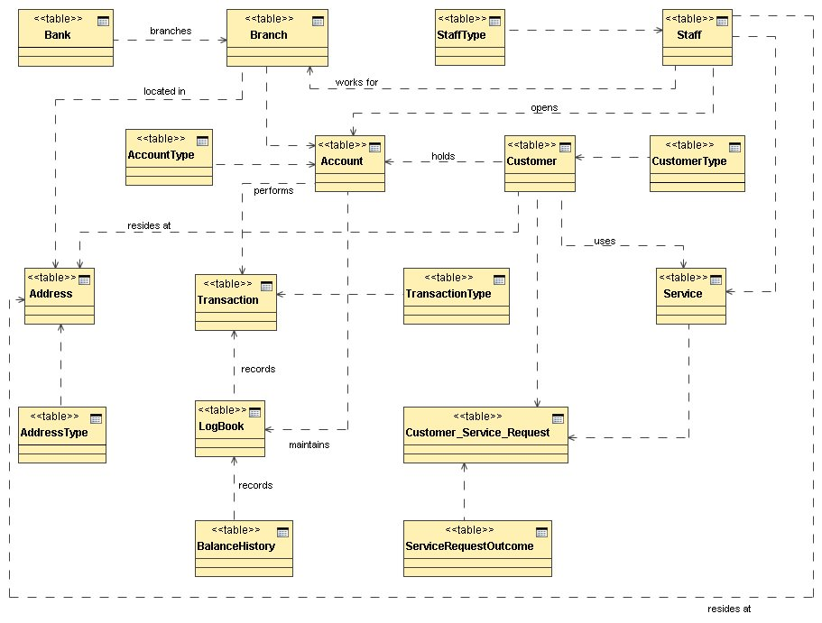
Figure 1: Class Diagram for Battle Town’s Bank of Britain

  - Associated Tables Description
The section shown here outlines the entities along with their associated name, description, relationships and a brief discussion on each entity. Primary keys are shown with underlined text and foreign keys are marked using * in the beginning of the attribute.

    - BANK
The BANK entity stores the records of banks. For example each record stores name of the bank and a unique ID as primary key to identify it. This entity is defined as to perform electronic fund transfer between two accounts which may be either between same banks or different banks. The entity has a one-to-many association with Branch entity. As a bank can have many branches in different areas of a city.
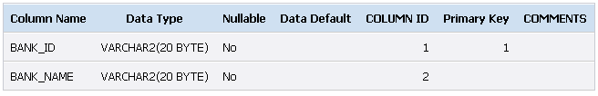
Figure 2: BANK Entity Structure
    - BRANCH
The BRANCH entity holds a list of branches for a particular bank. This is the child entity for BANK and STAFF entity and parent entity for ADDRESS and ACCOUNT entities. There are four attributes of this entity (See Figure 3). The primary key attribute is SORT_CODE which is unique among different branches.
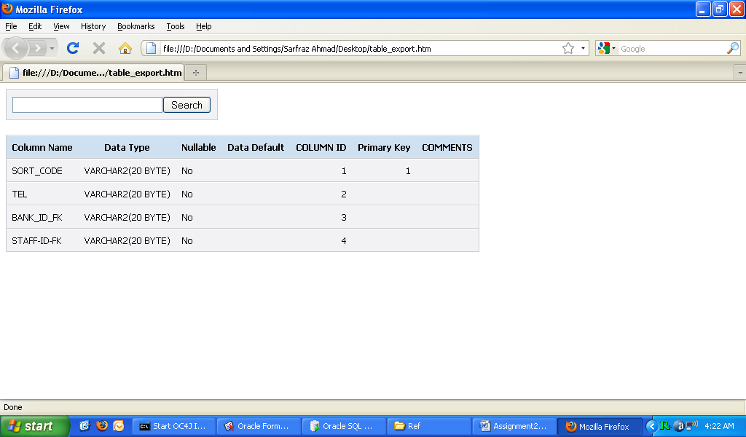
Figure 3: BRANCH Entity Structure

    - ADDRESS and ADDRESS_TYPE
The ADDRESS entity keeps record of information about the address for BRANCH, STAFF and CUSTOMER independently performing parent role. It is associated with ADDRESS_TYPE which records type of address with one-to-many relationship as a child entity. Figure 4 shows the structure of this entity. The primary key attribute is ADDRESS_ID which is unique among different associated entities marked with FK at the end of attributes.

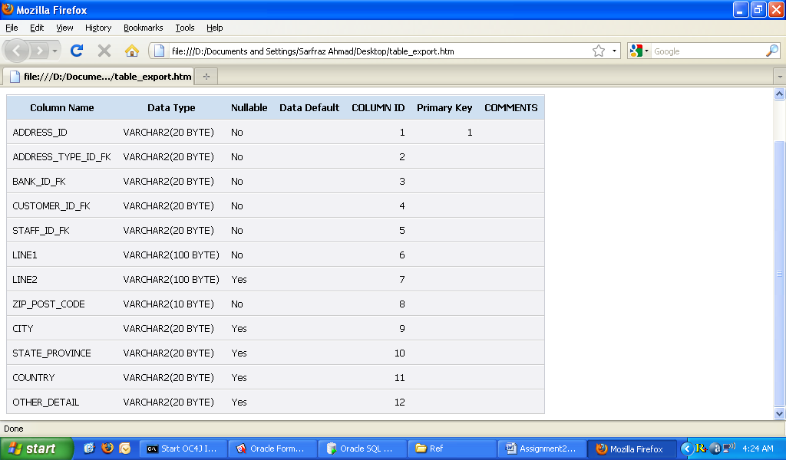
Figure 4: ADDRESS Entity Structure

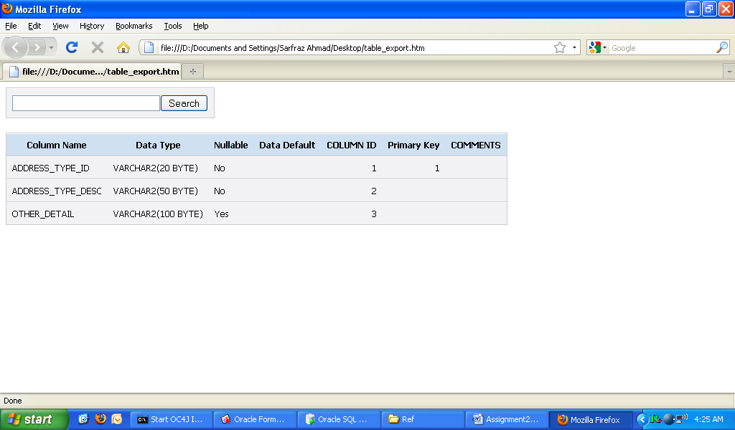
Figure 5: ADDRESS Entity Structure

    - STAFF and STAFF_TYPE
The STAFF entity is included in design to give them to accounts. In our case finished system, the STAFF is the main user of the whole system. It is linked with ADDRESS, SERVICE and CUSTOMER entities independently performing parent role. As staff lives at a particular address, fulfils services requested and may also be the customer of the same branch s/he is working. It is associated with STAFF_TYPE with One-to-Many relationship as a parent entity. Figure 6 shows the structure of STAFF entity with primary key attribute of entity as STAFF_ID and some foreign keys attributes too.

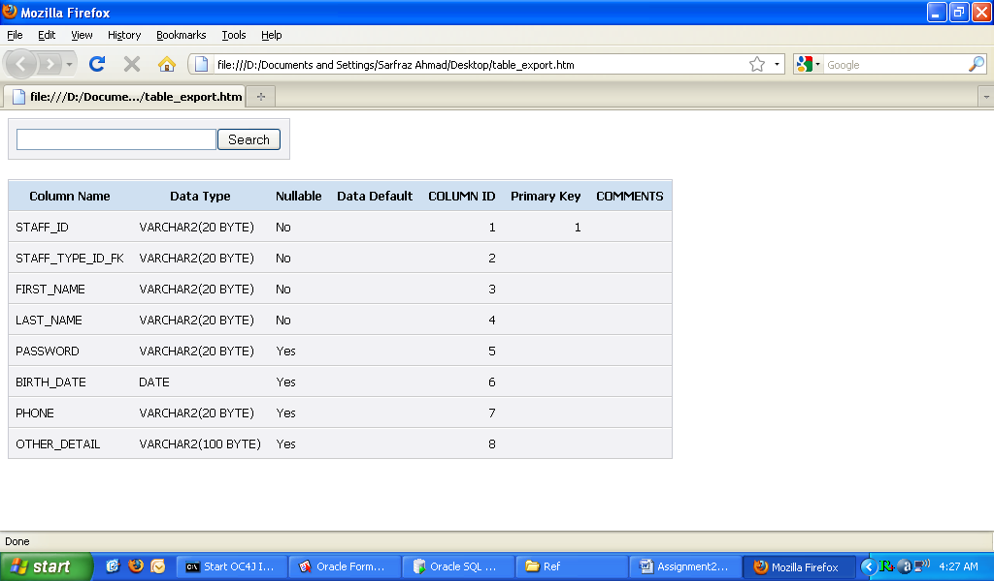
Figure 6: STAFF Entity Structure

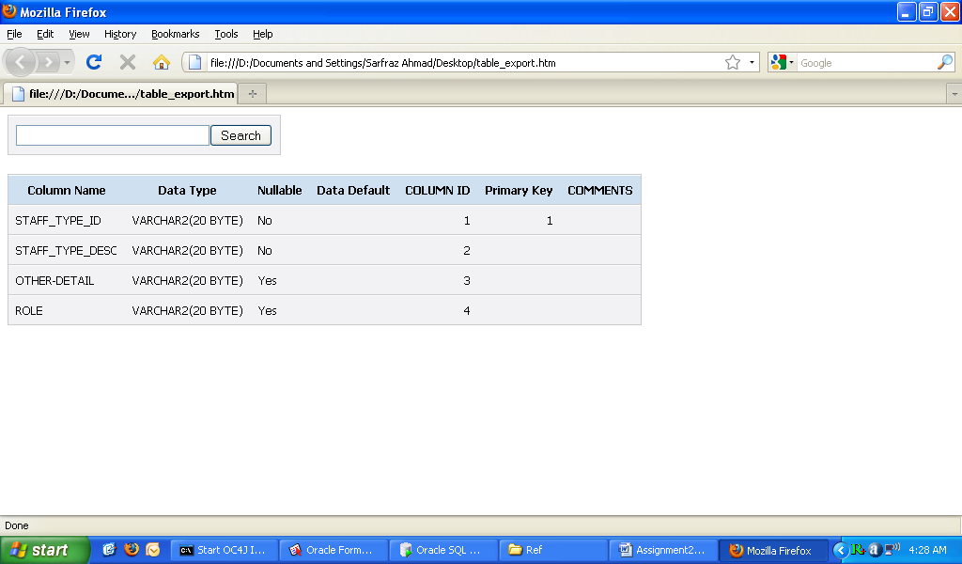
Figure 7: STAFF_TYPE Entity Structure

    - CUSTOMER
CUSTOMER entity is included to separate the customer’s profile and accounts detail. It is linked with ADDRESS, SERVICE, ACCOUNT and ACCOUNT_SERVICE_REQUEST entities independently performing parent role. It is associated with CUSTOMER_TYPE with One-to-Many relationship as a parent entity. Figure 8 shows the structure of CUSTOMER entity with primary key attribute of entity as CUSTOMER_ID and a foreign key attribute.

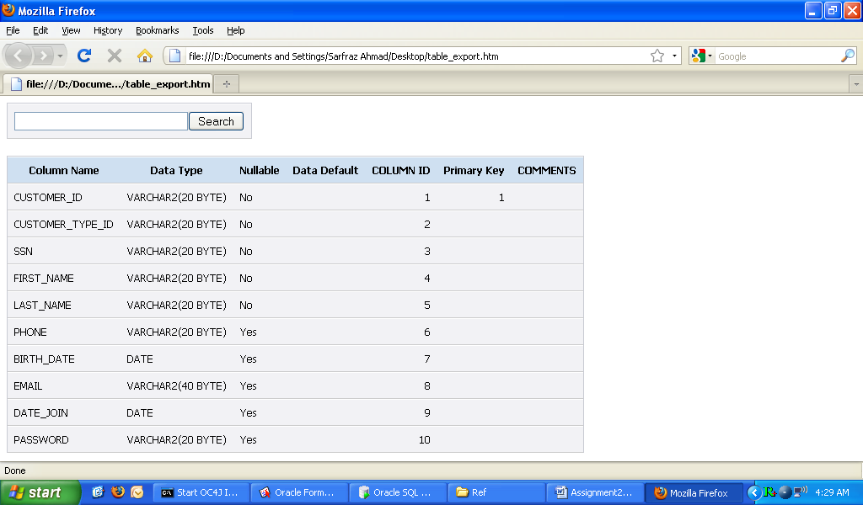
Figure 8: STAFF_TYPE Entity Structure

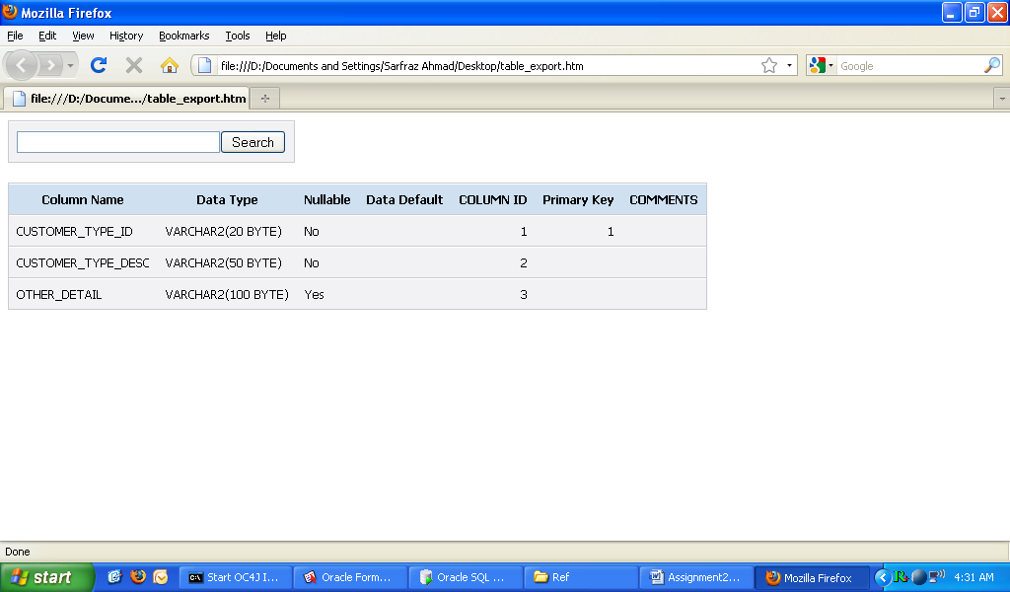
Figure 9: CUSTOMER_TYPE Entity Structure

    - ACCOUNT
Each customer has one or more accounts in a branch. It also belongs to TRANSACTION and LOG_BOOK entities as a parent. As each account performs zero or more transactions and there is a log book maintained for each account. It is connected with CUSTOMER, BRANCH and ACCOUNT_TYPE entities with One-to-Many relationship as a parent entity. Figure 10 shows the structure of the ACCOUNT entity with ACCOUNT_ID as primary key attribute and three foreign key attributes.
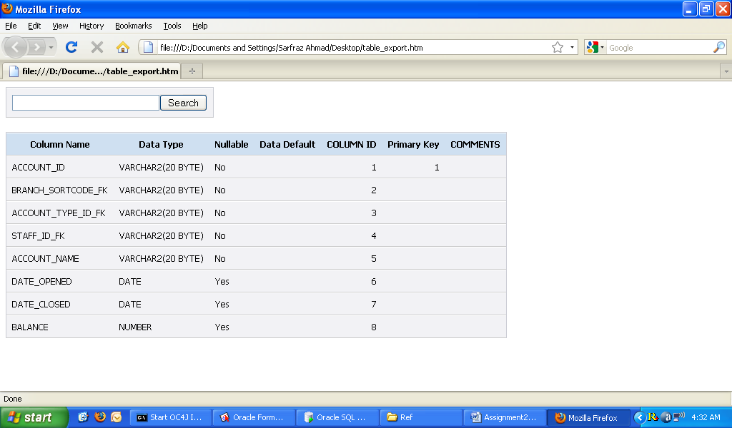
Figure 10: CUSTOMER_TYPE Entity Structure

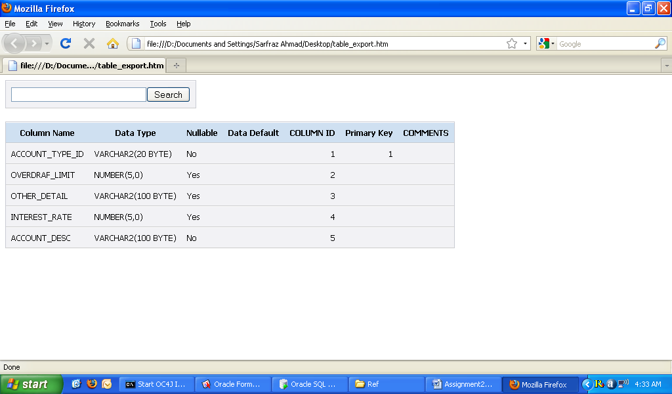
Figure 11: ACCOUNT_TYPE Entity Structure

    - LOG_BOOK
The purpose of the entity is to record each the transaction done and balance on each transaction. Hence, it is connected with TRANSACTION and BALANCE_HISTORY entities as parent with one-to-many relationship. The entity is also related to ACCOUNT as a child. A primary key is designated for each log book with foreign keys to BALANCE_HISTORY and ACCOUNT entities.
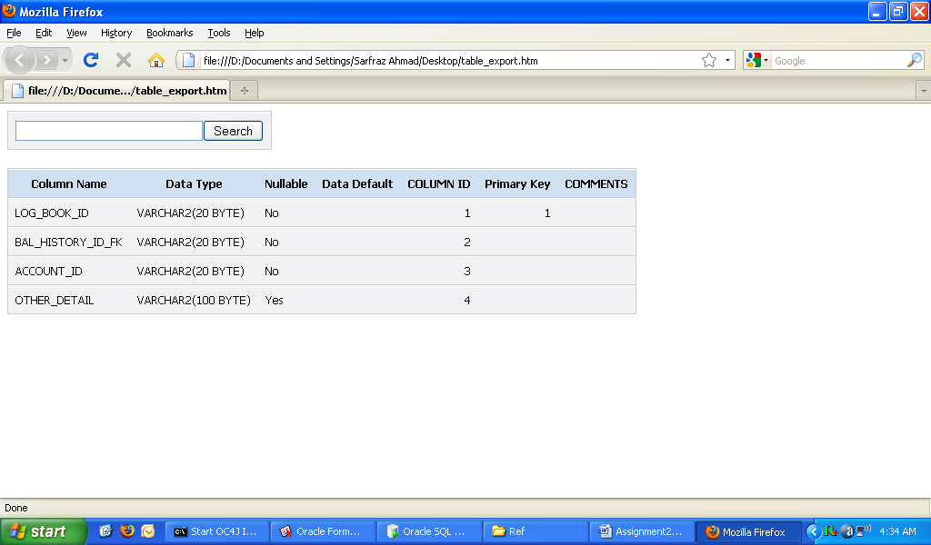
Figure 12: ACCOUNT_TYPE Entity Structure

    - TRANSACTION
A TRANSACTION is another key entity of the case study. It also belongs to TRANSACTION_TYPE, ACCOUNT and LOG_BOOK entities as a parent entity with one-to-many relationship. As each transaction has a type like deposit or withdrawal and is related to an account, there is a log book maintained for each transaction. Figure 13 shows the structure of the TRANSACTION entity with TRANS_ID as primary key attribute and three foreign key attributes. Figure 14 shows the structure of TRANSACTION_TYPE entity.
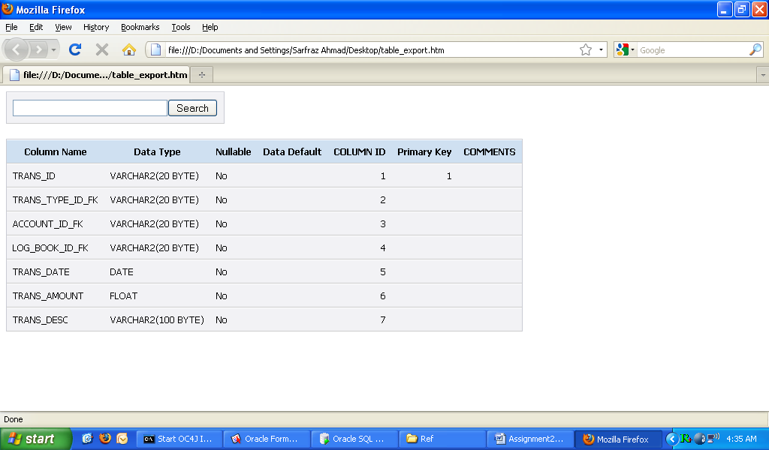
Figure 13: TRANSACTION Entity Structure

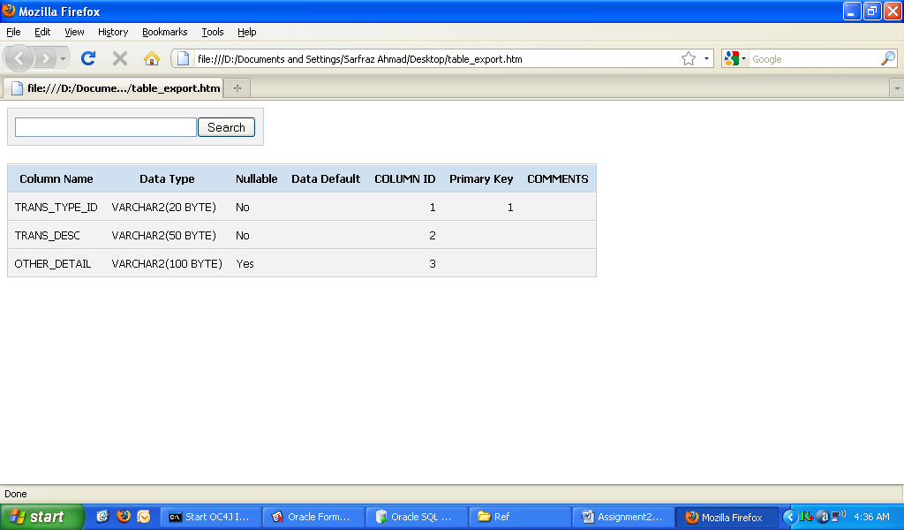
Figure 14: TRANSACTION_TYPE Entity Structure

    - SERVICE
A bank must provide additional services to its customers to fulfil their needs in a way they feel comfortable. It also belongs to STAFF, CUSTOMER as parent entity with one-to-many relationship. For example, staff is responsible for fulfilling the requests initiated by customers. Service is either sending a cheque book or special statements for specific period of time. When a request is initiated it is recorded in CUSTOMER_SERVICE_REQUEST entity that works as child entity of SERVICE with 1:N relationship. Figure 15 shows the structure of the SERVICE entity with SERVICE_ID as primary key attribute and two foreign key attributes.

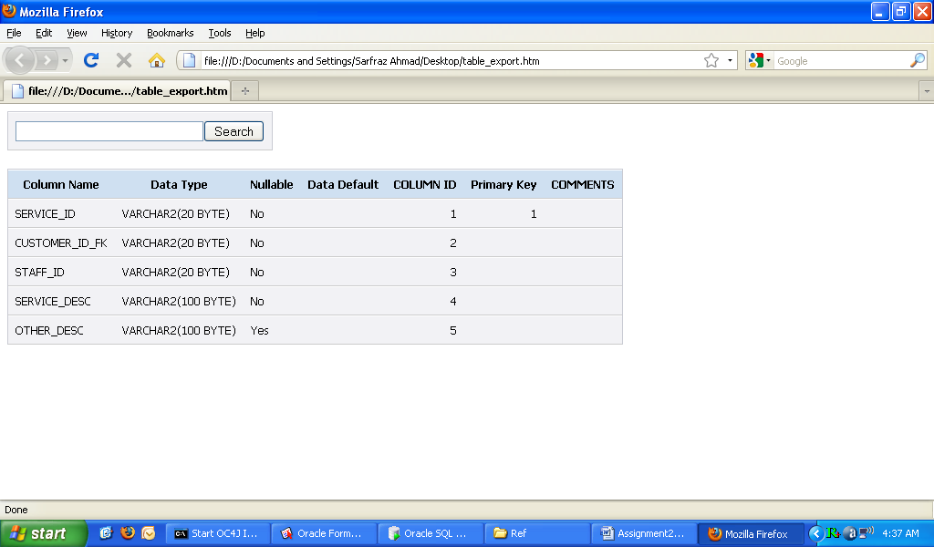
Figure 15: SERVICE Entity Structure

    - SERVICE_REQUEST_OUTCOME, BANK and CUSTOMER_SERVICE_REQUEST
It is important to keep track of the service requested by a customer and fulfil those which are yet not completed. SERVICE_REQUEST_OUTCOME entity records the status of the requests either completed, incomplete or cancelled. It is linked with SERVICE as parent entity with 1:N relationship. Figure 16 shows the structure of TRANSACTION_TYPE entity with a primary key attribute SVC_REQ_OUT_ID. Figure 18 shows the structure of the BALANCE_HISTORY entity with links CUSTOMER and SERVICE tables to keep track of services requested by a customer as a parent table. When a request is initiated it is recorded in CUSTOMER_SERVICE_REQUEST entity that works as child entity of SERVICE with 1:N relationship.

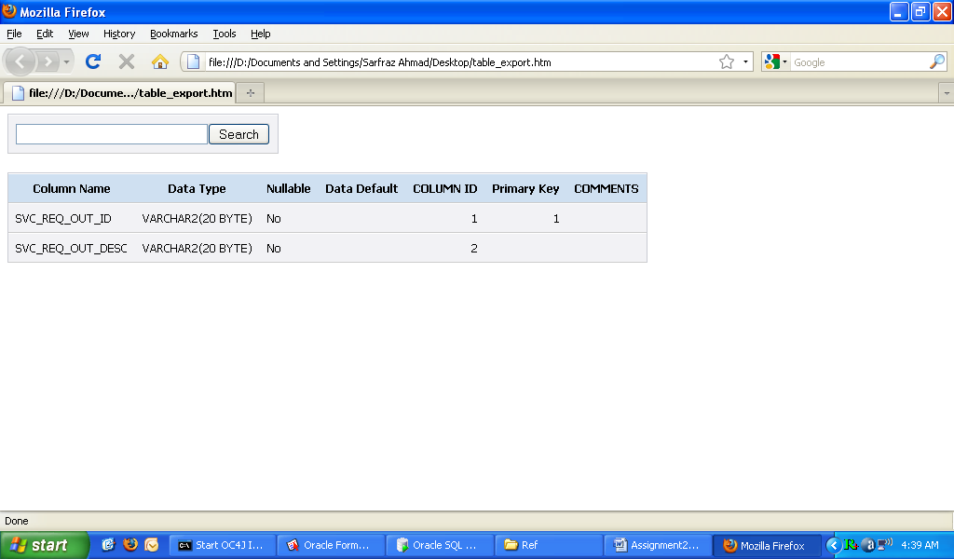
Figure 16: SERVICE_REQUEST_OUTCOME Entity Structure

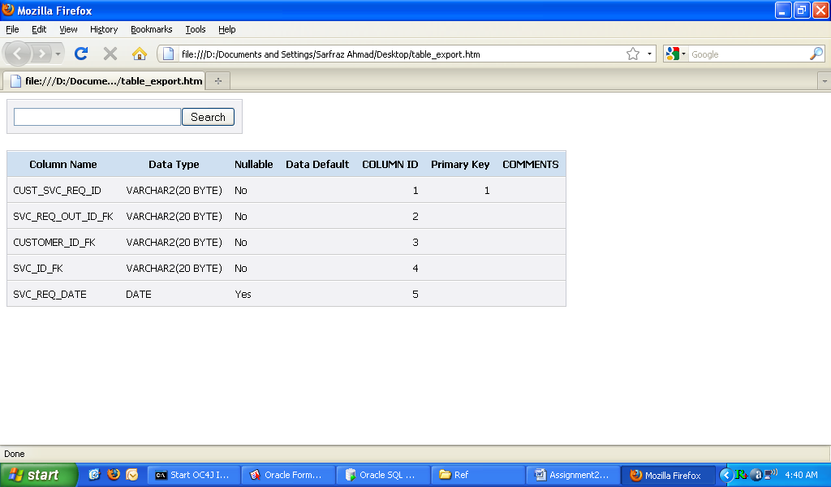
Figure 17: CUSTOMER_SERVICE_REQUEST Entity Structure

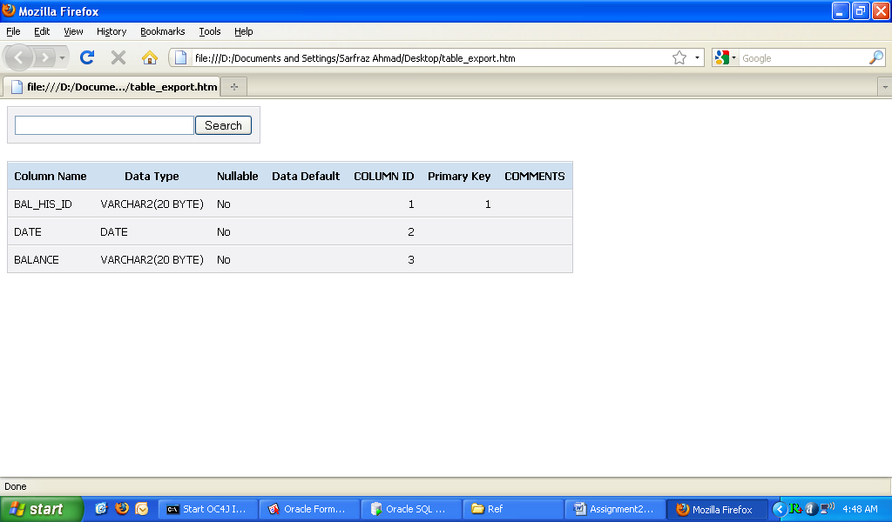
Figure 18: BALANCE Entity Structure

  - SAMPLE DATA
The section provides the sample data for the above mentioned tables to demonstrate the domain of each attribute.

    - BANK
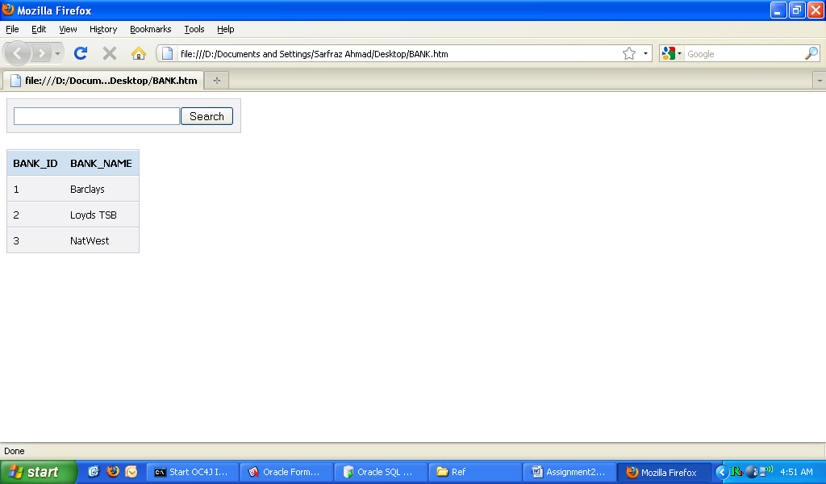

    - BRANCH
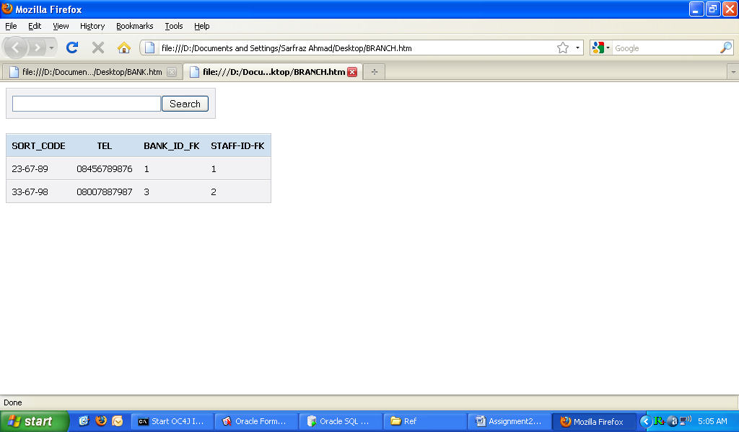
    - ADDRESS
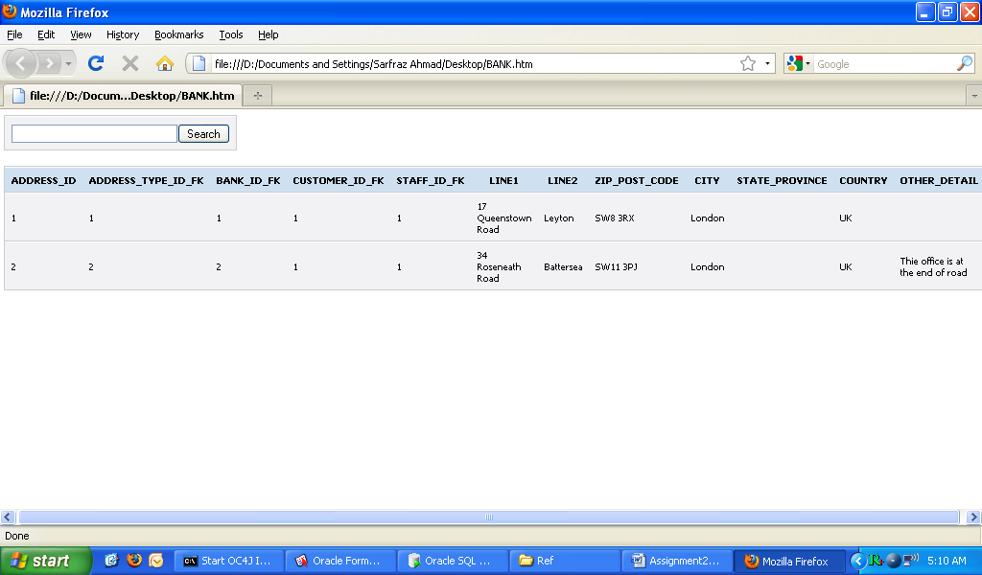
    - ADDRESS_TYPE
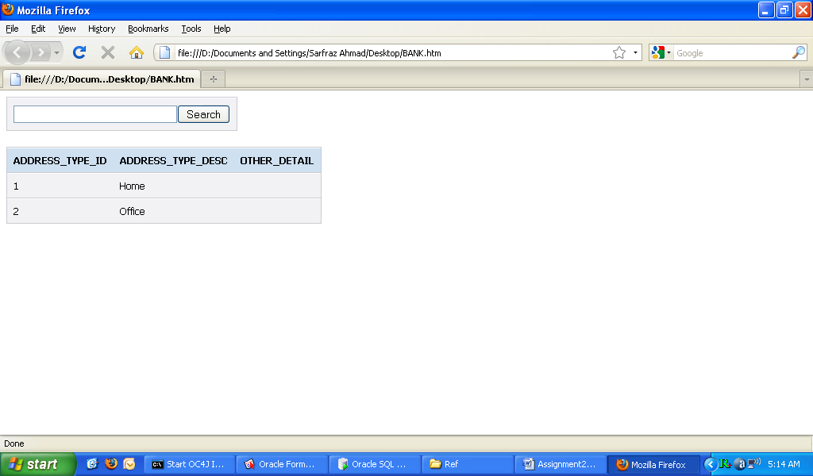

    - STAFF
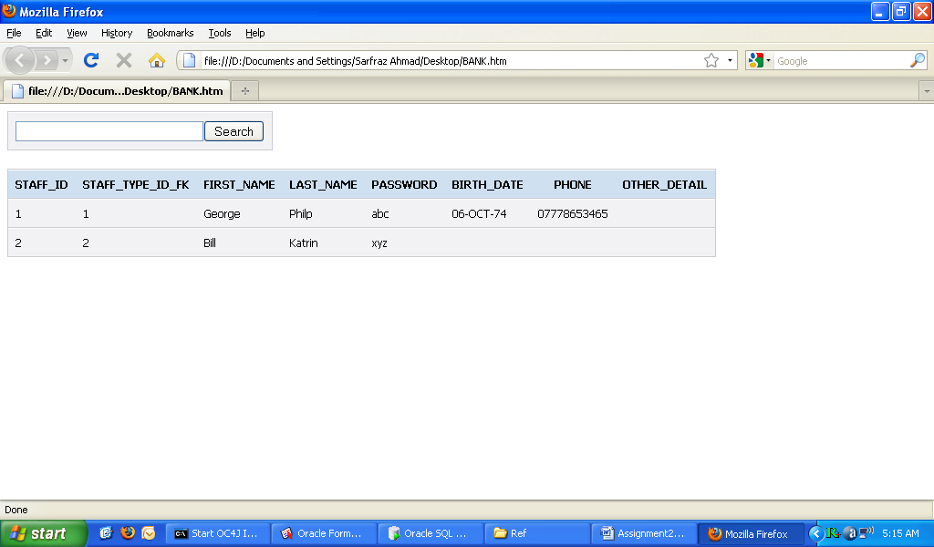

    - STAFF_TYPE
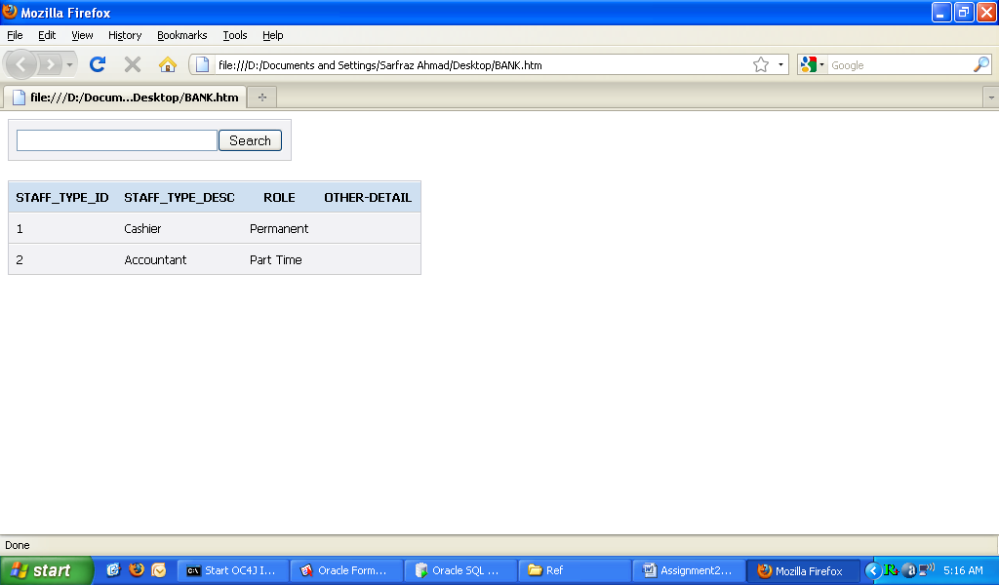
    - CUSTOMER
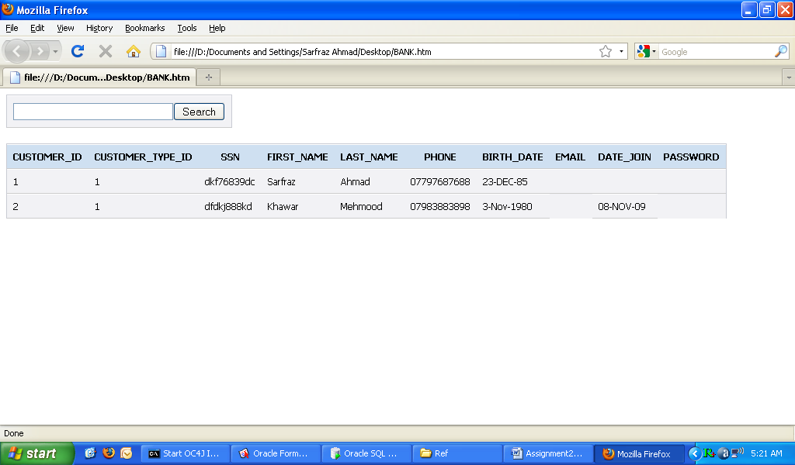
    - CUSTOMER_TYPE
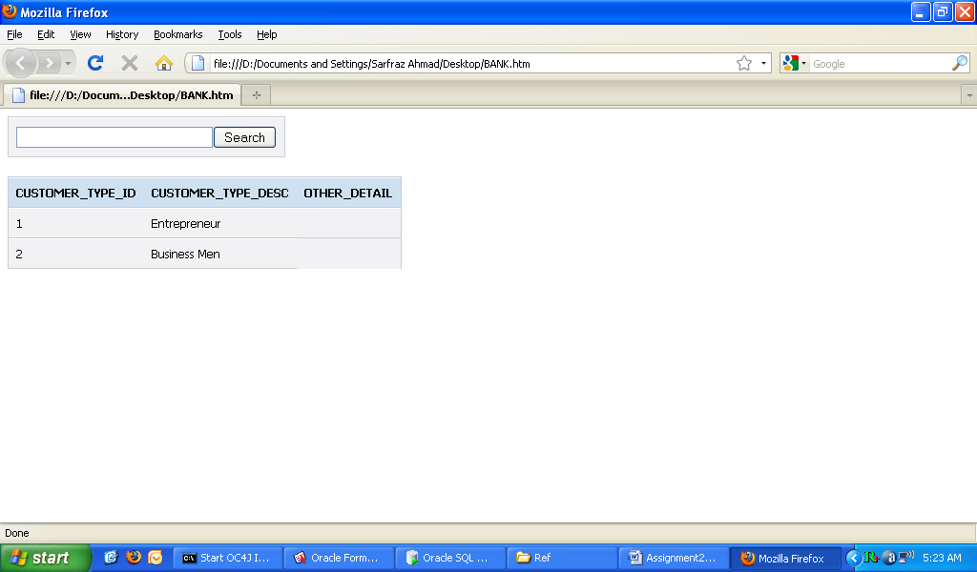

    - ACCOUNT
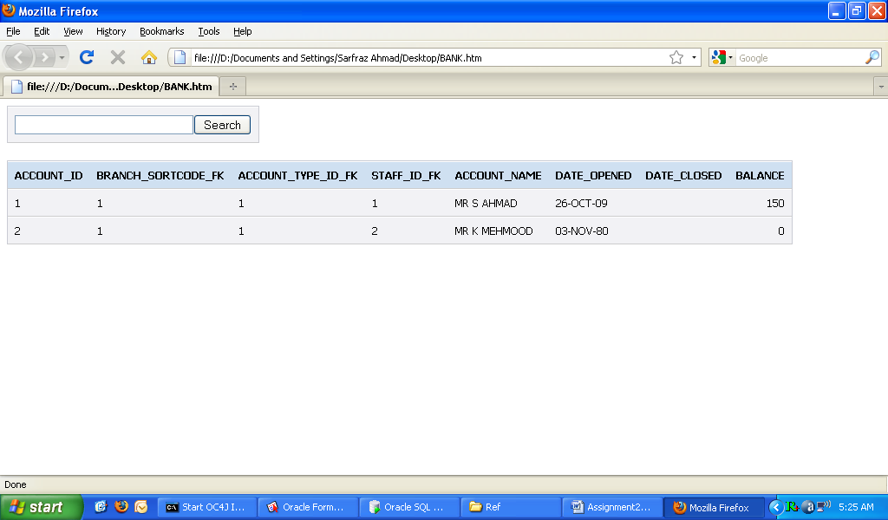
    - ACCOUNT_TYPE
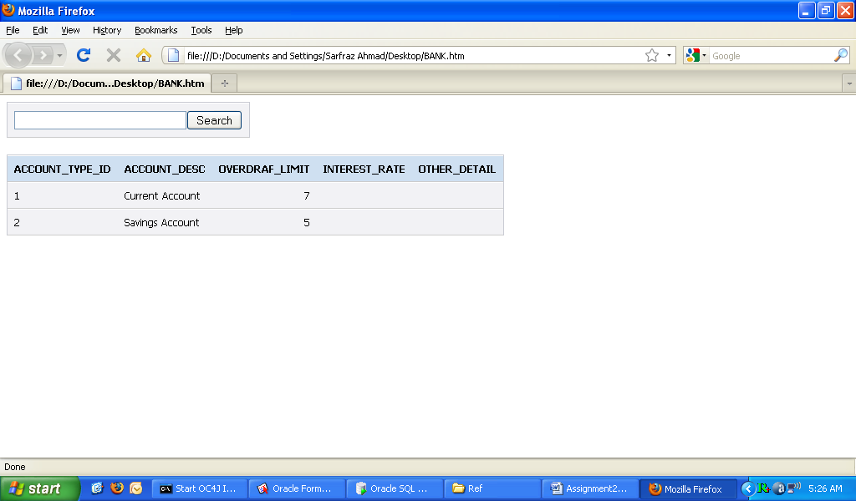
    - LOG_BOOK
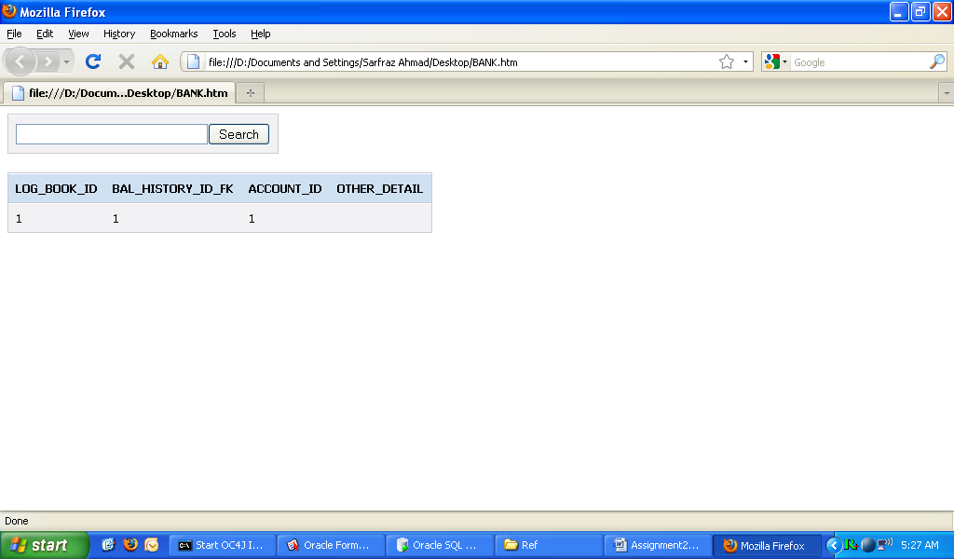
    - TRANSACTION
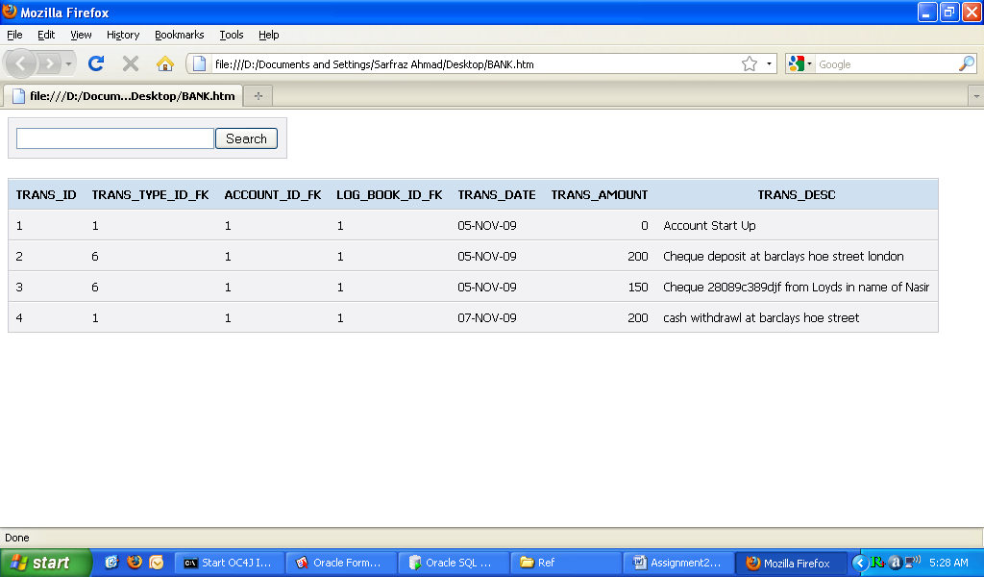

    - TRANSACTION_TYPE
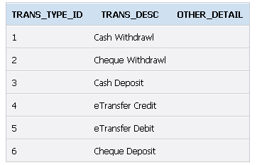

    - SERVICE
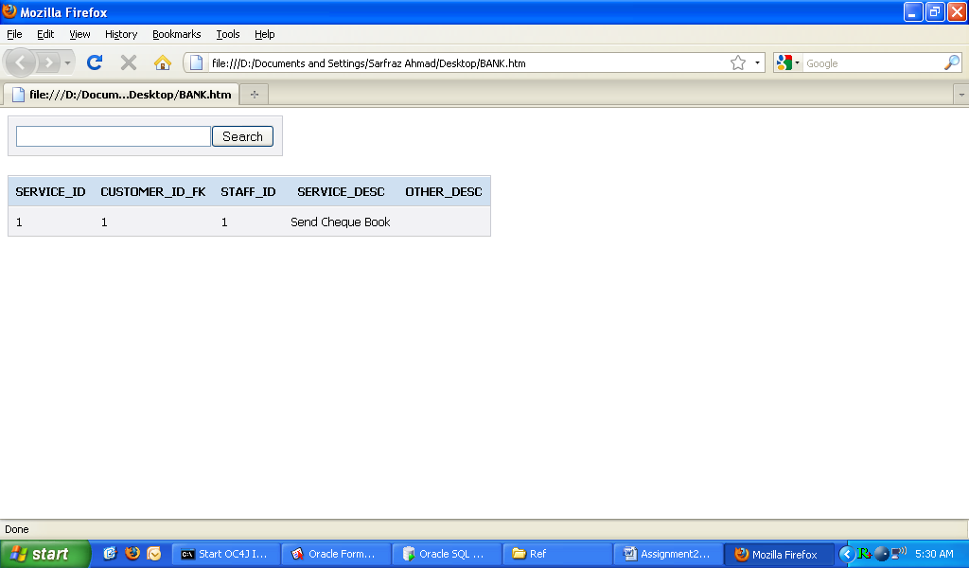

    - SERVICE_REQUEST_OUTCOME
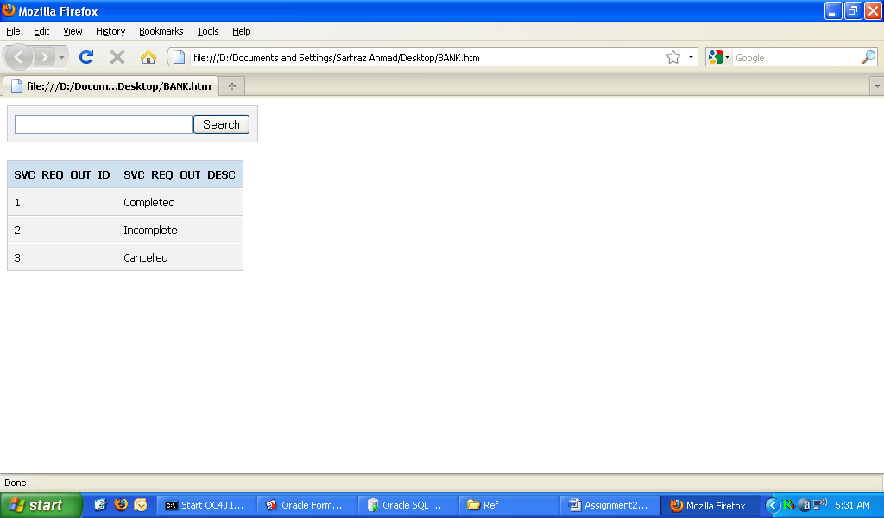

    - CUSTOMER_SERVICE_REQUEST
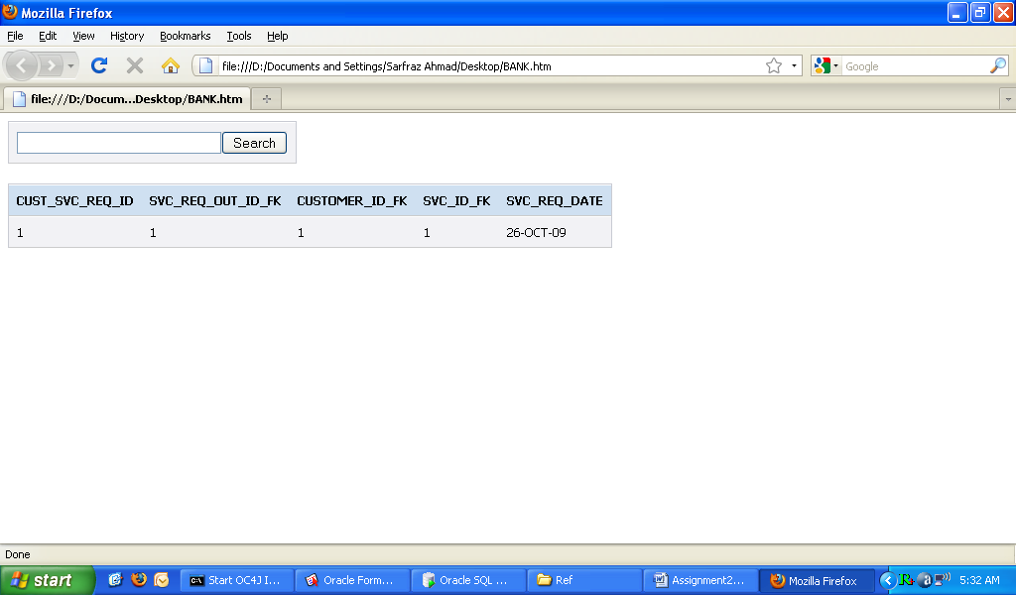

Task 2
Implementation (Functionality and HCI)
This section of the report describes and shows the sample transactions developed for the case study. The transactions are selected from both types of transactions including debit and credit of money using either in cash or by cheque to demonstrate the understanding of the Oracle development.
  - Functionality and Features Developed in System
In this part of the report, the three transactions including cash, cheque deposit and cheque withdrawal will be explained in detail and depth. The aim the section is to highlight and demonstrate the HCI features and implementation of the transactions built using Oracle Forms 10g.
      - Main Menu Screen
It is always practical and easy for users to use the application if they are provided with a system architected on the HCI principles. Hence, menus and toolbars are mostly known these days in all modern software applications to group the logical and coherent activities. The same concept is provided by Oracle Forms that has been employed in developing the given cash study system. The Figure 19 shows the welcome screen for the developed application.
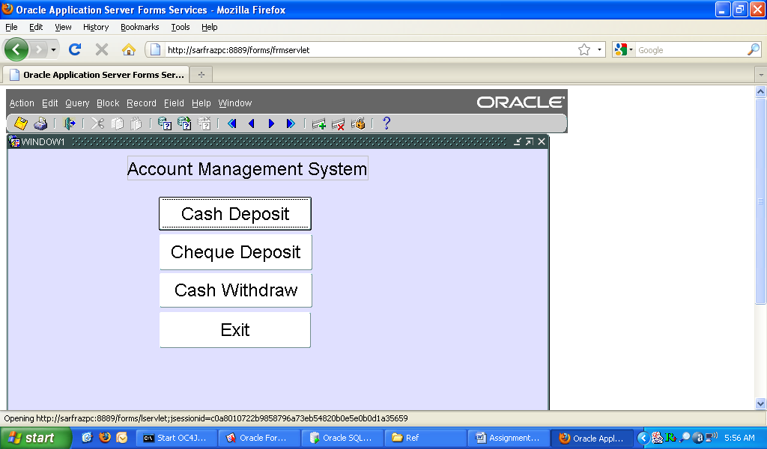
Figure 19: Welcome Screen of the Battle Town’s Accounts Management System

      - Cash Deposit Screen
Cash deposit facility is provided to bank staff to access system and deposit the cash into a customer’s account. Staff can deposit the cash by clicking on Cash Deposit button, which in return will pop-up a window. The Figure 20 shows the cash deposit screen with all fields that are required for the transaction. The proceeding sections of the will illustrate the sample inputs to the system to test the working of the developed system.
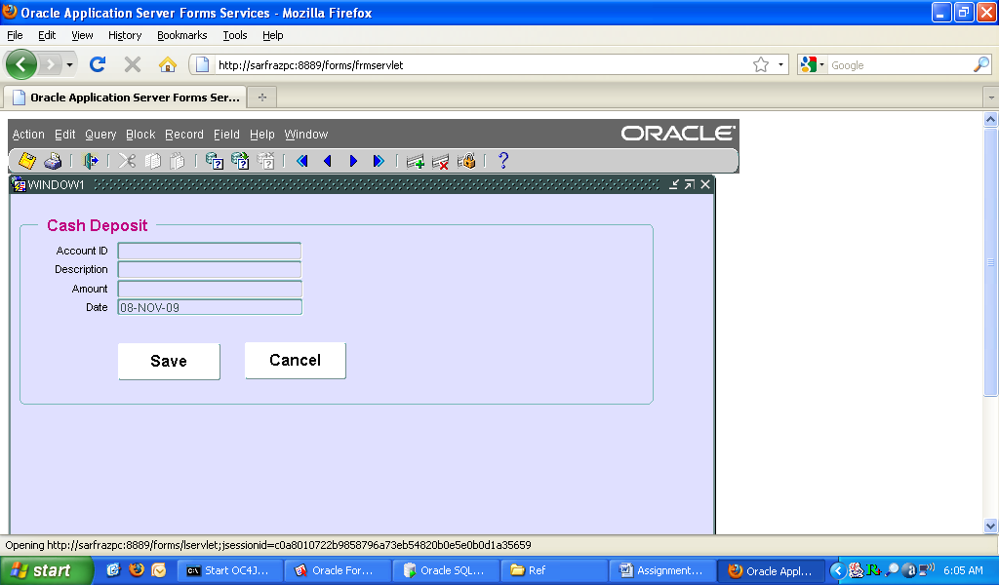
Figure 20: Cash Deposit Screen

      - Cheque Deposit Screen
Clicking the Cancel button will allow the staff to go to the main menu (welcome screen). The second most frequently used functionality is cheque deposit to allow the staff to enter a cheque deposit into a customer account. The Figure 21 shows the cheque deposit screen with mandatory inputs required.
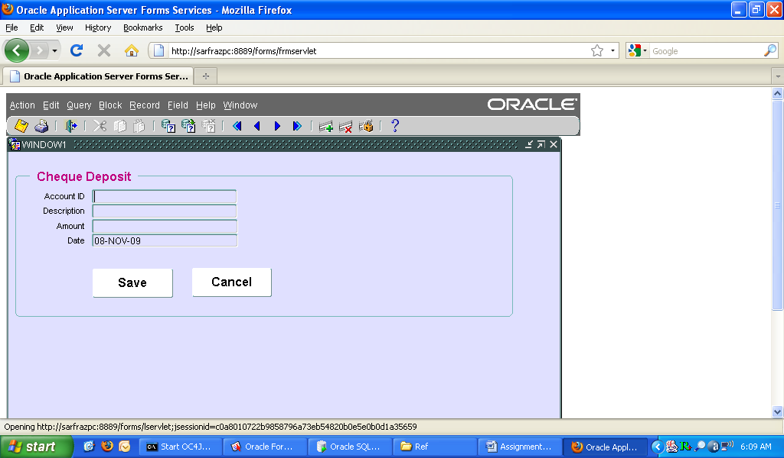
Figure 21: Cheque Deposit Screen
      - Cash Withdrawal Screen
The functionality developed in the system is cash withdrawal, which permits the staff member to withdraw the required amount from a customer account. Again, this is the essential and required part of any banking application software. The Figure 22 shows the cash withdrawal screen.
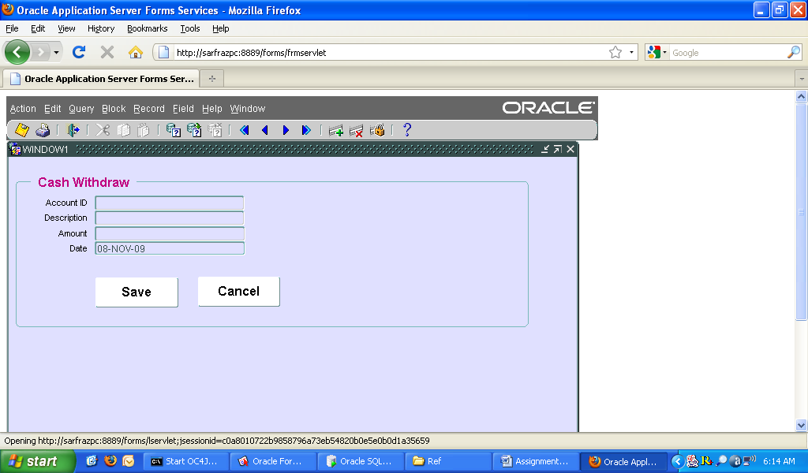
Figure 22: Cash Withdrawal Screen

Task 4
Test Plan and Evaluation
After the system has been implemented, the next process in SDLC is testing where an appropriate test methodology is used along with a detail intention of finding bugs (run time errors including logical errors, compatibility errors and other non-functional parameters). The process is called V&V (Verification and Validation) to ensure developed software (Sommerville, 2008):

- Meets the business and technical requirements that guided its design and development
- Works as expected and
- Can be implemented with the same characteristics

The task in this section of report is to use the black-box testing methodology to verify and validate the developed system in accordance with the specification of the given case study with a set of different realistic input data. Black-box testing is used as does not bond the tester with the code; with a perception a code must have bugs. This technique is used as it allows the tester to test the system without knowing the internal (code) of the software and concentrate only on give and get philosophy. Hence, testers can find the bugs and errors where programmer can’t. As a result
- Possible test cases (See Appendix-B) have been listed to check something that might cause an error or bug in system.
- Some parts of the back-end are skipped at all, as tests are done only at unit and integration levels with a minimal software component, or module where each unit (transaction) of the software is tested to verify that the detailed design for the unit has been correctly implemented.

Test Plan
The test method employed to carry out the relevant tests to verify the system is equivalence partitioning. As of the rule of equivalence partitioning it has been tried to test the cases with one correct input and at least one erroneous input. This part of the report carries out the tests relevant to the system providing a real sample test runs
(screen dumps) together with showing the output of each function of the system.

  - Testing the Transactions
The section of the report tests the sample transactions developed for the case study to verify and validate. The unit testing is performed for each of the transaction to understanding of testing techniques and process.
    - Money In (Deposit)
To debit the money the system developed provides two methods using cash or cheque.
      - Cash Deposit
Cash deposit is a common method of depositing money into an account. The developed system provides this facility to allow the staff to deposit the money. The section shows each of the screens with sample input values.

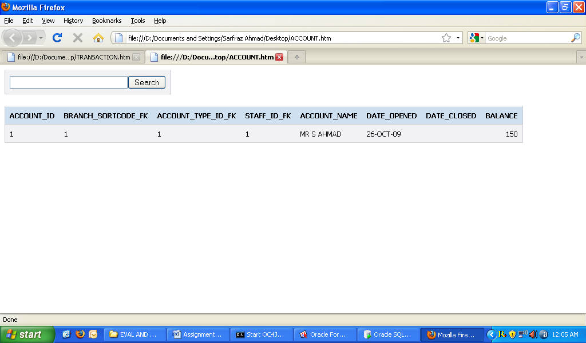
Figure 22: Balance before any Transaction

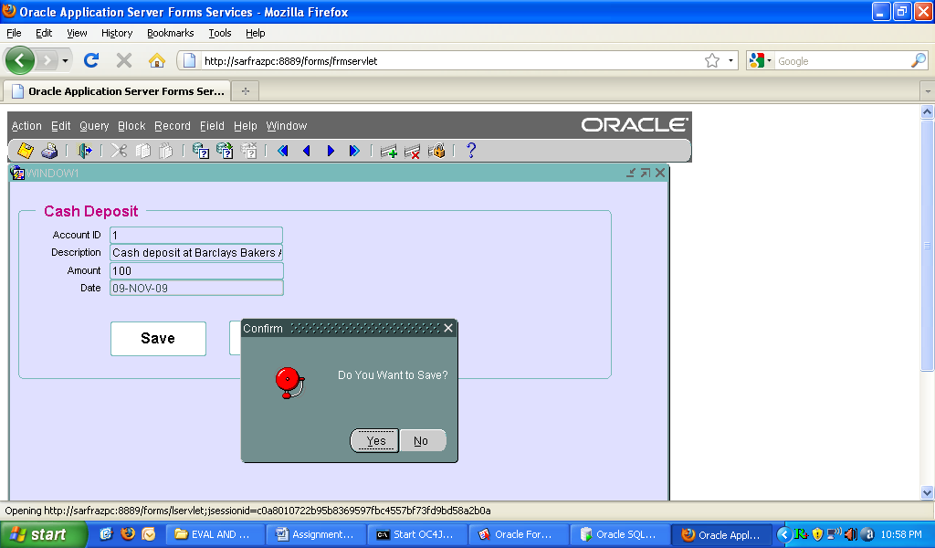
Figure 23: Cash Deposit Confirmation

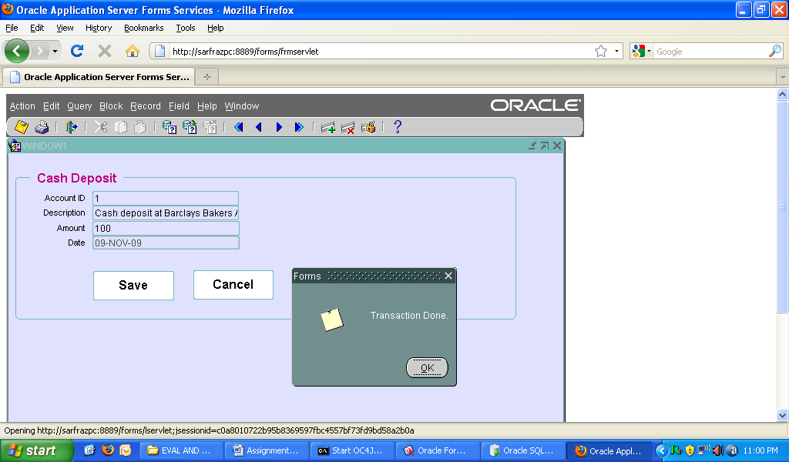
Figure 24: Cash Deposit Completion

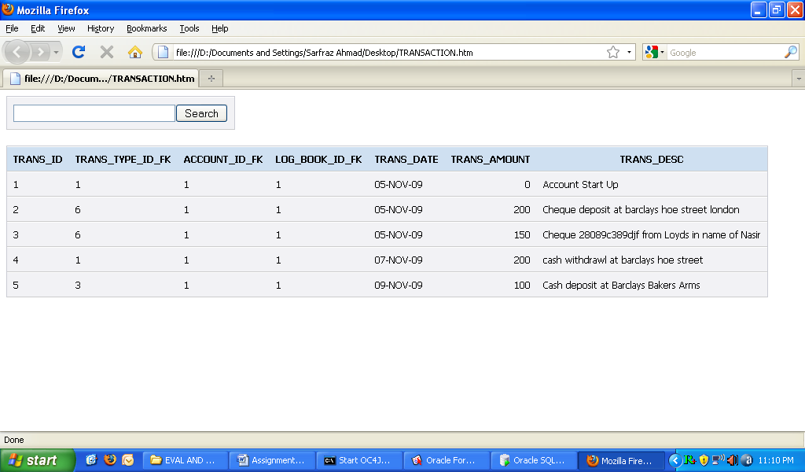
Figure 25: Verification of Cash Deposit Transaction

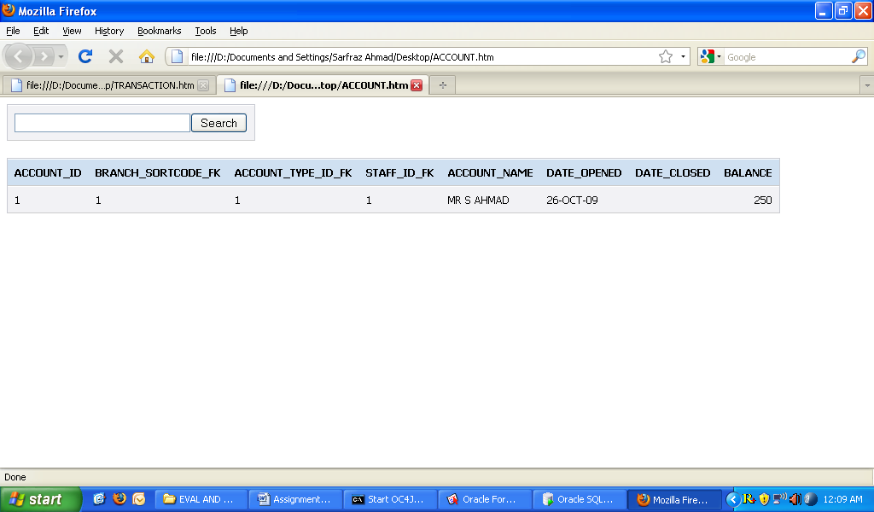
Figure 26: Account Balance Updated after Cash Deposit

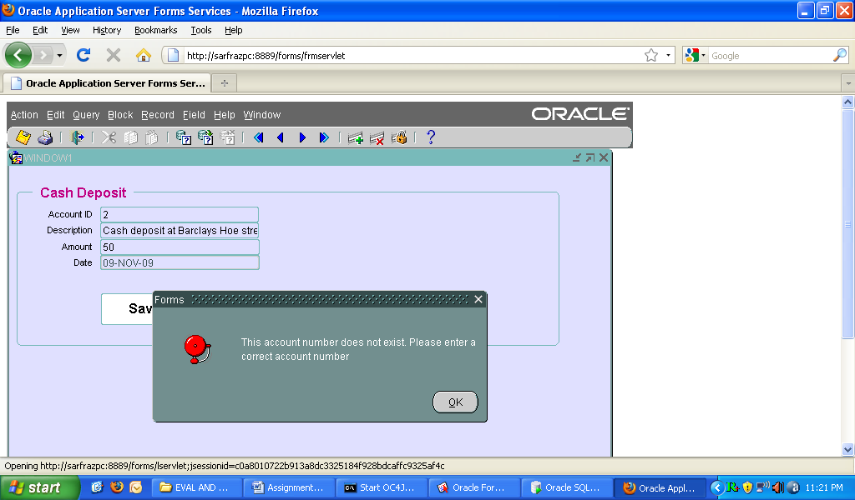
Figure 27: Cash Transaction with Invalid Account Number

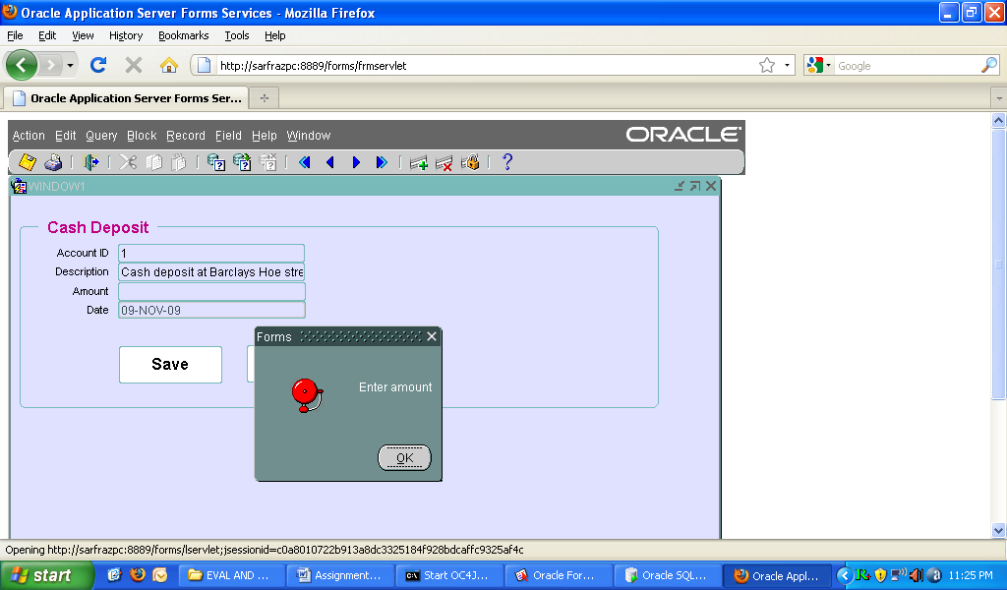
Figure 28: Blank User Inputs

      - Cheque Deposit
Depositing money using cash is also worth in banking systems. This section demonstrates steps to be followed to deposit money by cheques and show the success of the transaction with sample input and output.
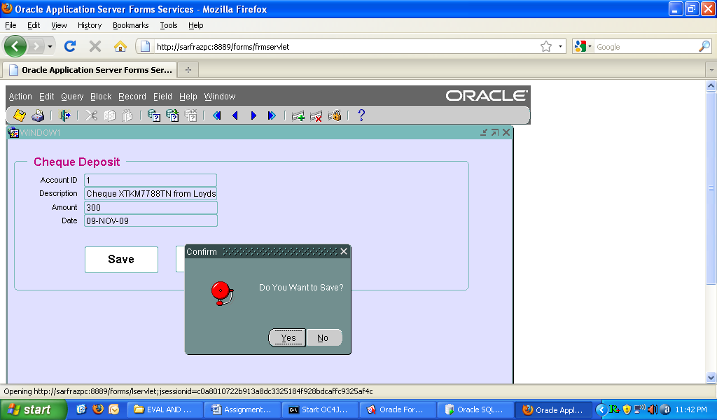
Figure 29: Blank User Inputs

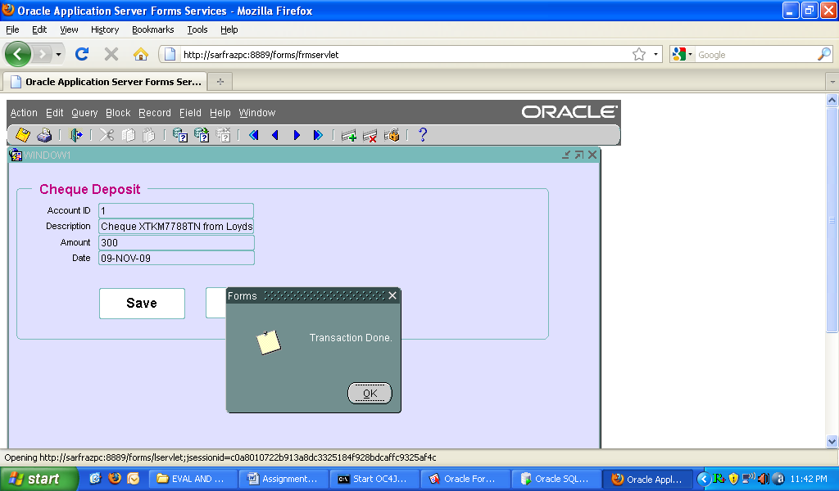
Figure 30: Cheque Deposit Verification

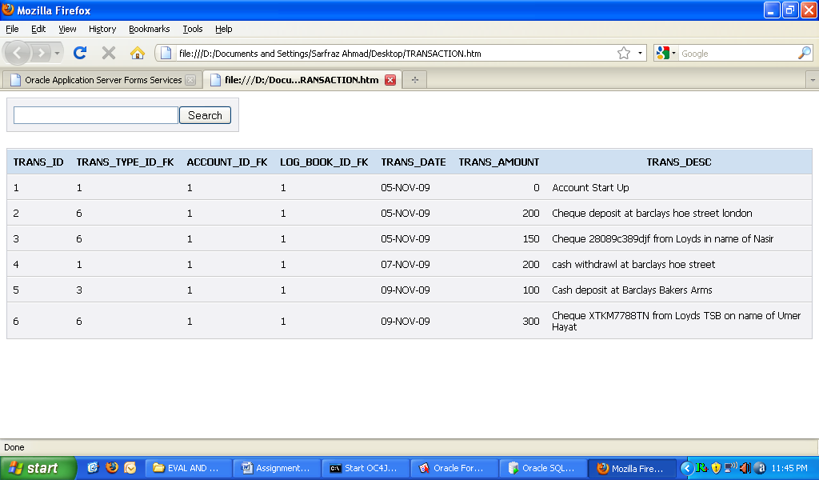
Figure 31: Cheque Deposit Verification

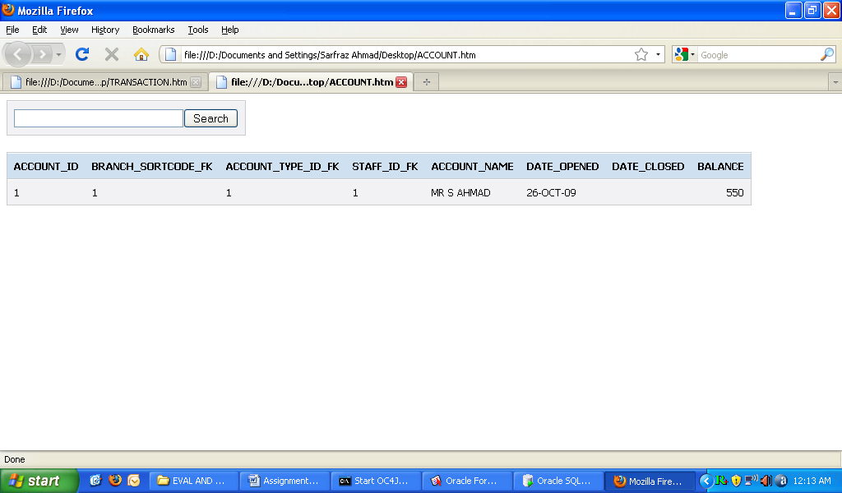
Figure 32: Account Updated after Cheque Deposit

      - Cash Withdraw Transaction
Depositing money using cash is also worth in banking systems. This section demonstrates steps to be followed to deposit money by cheques and show the success of the transaction with sample input and output.
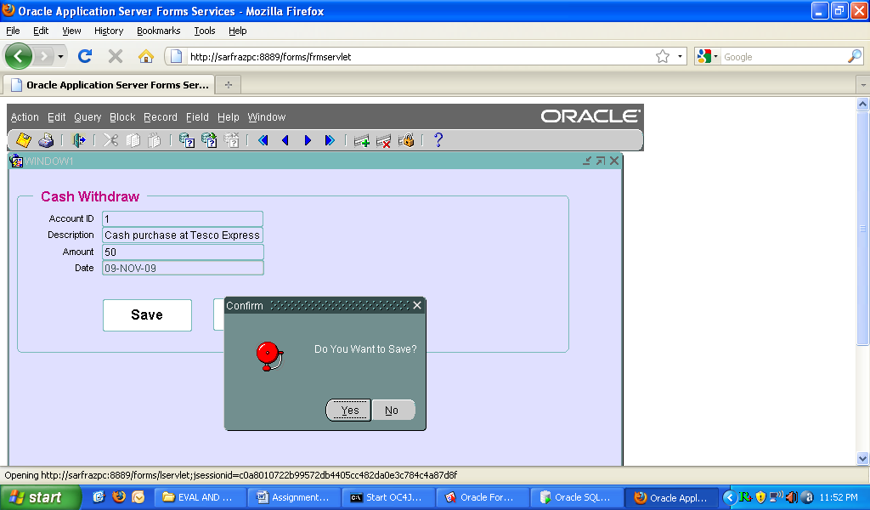
Figure 33: Account Updated after Cash Withdrawal

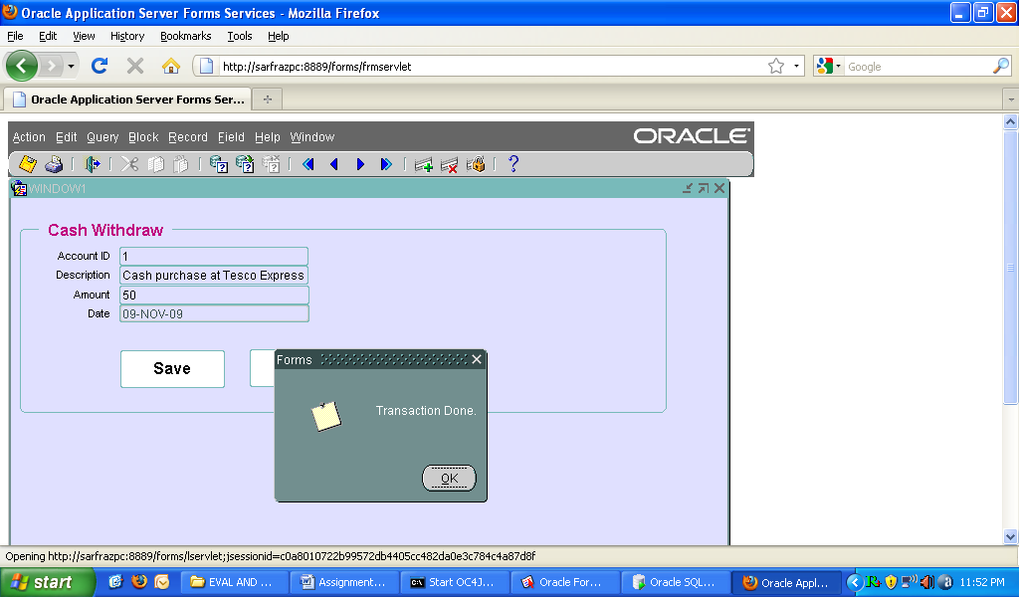
Figure 34: Cash Withdrawal Verification

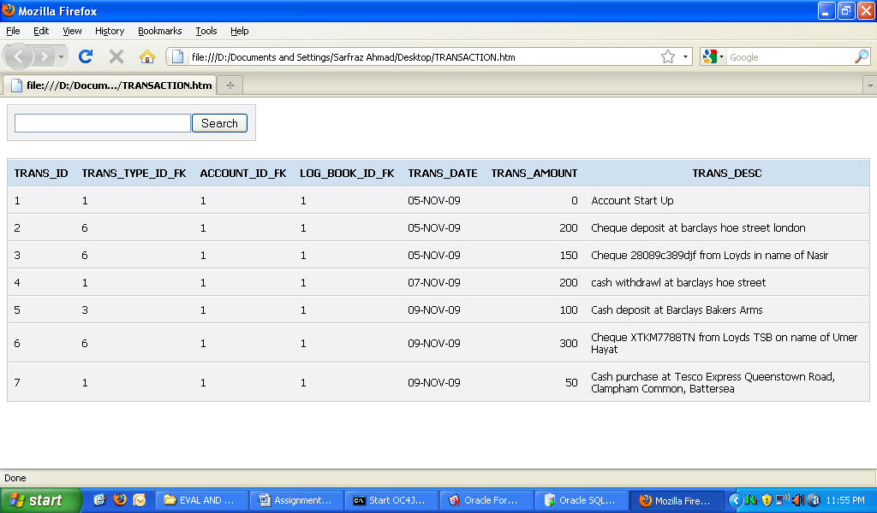
Figure 35: Cash Withdrawal Verification

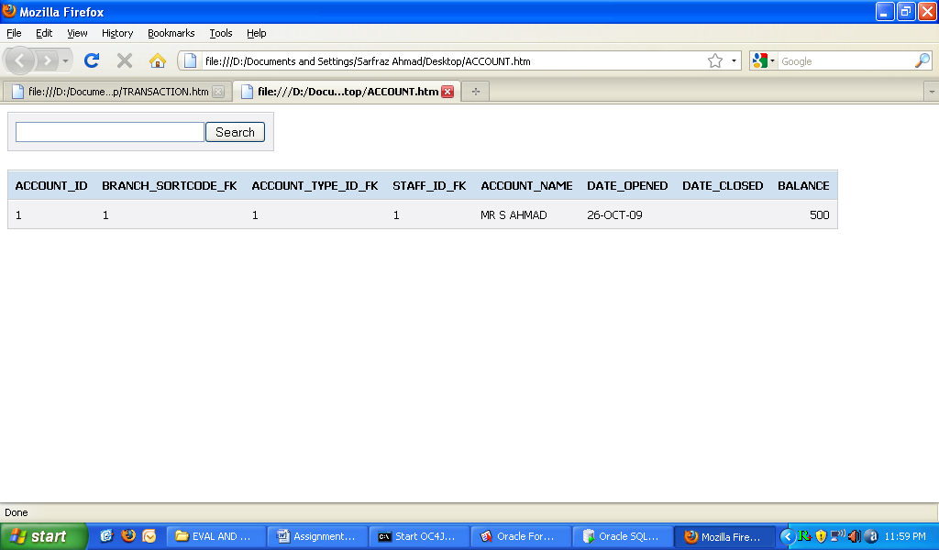
Figure 36: Account Balance Updated After Cash Withdrawal

Task 5
Overall Evaluation and Enhancements
There are a number of common software measures, often called "metrics", which are used to measure the state of the software or the adequacy of the testing. Software evaluation parameters may vary depending upon the nature of a system. For example, critical and safety control system require different levels of evaluation than an entraining game application. The report evaluates the developed system in terms of client/server and distributed systems for an enterprise. Usually, quality is constrained to such topics as correctness, completeness, security, but can also include more technical requirements as described under the ISO standard ISO 9126, such as capability, reliability, efficiency, portability, scalability, maintainability, compatibility, and usability (Sommerville, 2006)..
  - Product Evaluation
Evaluation of the product is a very significant and important issue and involves the issues that guide the product success and its scope and scale in the future. It helps the management to analyze and weigh up the product based upon the critical factors that can promise the success or failure of the product. Software evaluation key factors are described in the proceeding section along with the measures that have been considered while evaluating.
    - Efficiency
- It can perform thousands of simultaneous requests per second
- Is it compatible with other hardware and operating systems
- It is flexible product, which can take advantages of other third party and commercial vendors including Sun, Microsoft and Open source technologies
    - Usability
- Product represents the simplest, most efficient way to accomplish the tasks.
- It is convenient, easy to use and learn with a good graphical interface.
    - Reliability
- Oracle guarantees the reliability of Oracle products.
- Product developed has been tested to ensure the reliability. Tests were successful 99% in test environment.
- Is the equipment accessible 24/7 365 days a year anywhere where Internet is accessible.
    - Scalability
- The system can be upgraded to process and handle more workload by adding new processors, devices and storage without shutting down the system.
    - Standards Conformance
Oracle technology confirms the standards, specifications and guidelines. Hence products developed are more reliable, scalable and secure. Interface standards, programming standards and navigation standards are the key factors that must be considered for victorious distributed systems (Tilson, et al, 2000).
  - System Enhancement
Man made products are never perfect and complete and there is always a need for advancement and enhancement that can be made to the existing products. As the man utilizes the product he always find some tweaks and weakness that cause to system to be less adaptable. This section explores the areas in which the developed software is identified to be enhanced and tweaked.
    - Advanced Search
The system does not provide users with advanced search facility, though basic default search functionality is available. System should allow the staff to
    - Electronic Cash Transfer
A good and modern banking system provides the user option for transferring cash online. This feature is not yet implemented in the current product and should be implemented to make the product more rewarding.
      - Direct Debit and Electronic Transfer
Direct debit is transfer of money to a company’s account on a specific date of each month when customer has an agreement to do so. Examples include monthly bill payments of gas, electric or contract mobiles or computers. Electronic transfer is another method of transfer money between accounts. These transactions are not implemented and must be developed for system completeness.
    - Reporting
Oracle provides Oracle Reports tool to help develop reports, the reporting is fundamental requirement of every business. The product developed can be enhanced by providing the weekly and month reports features which will help improve more user satisfaction and make the business procedures more efficient and accurate.
    - Security
The product developed does not provide user authorization and it does not possess the ability to protect data against unauthorized access, malicious, intelligent, adaptive attack, secure payment and protect advertent operations (Adriano & Arnaldo, n.d.) This could be achieved by providing a user authentication screen, running oracle on secure ports and different verification, password expiry, setting read-only file permission and encryption approaches.
    - System testing and system integration testing
The developed system is only tested at unit level, for the system to ensure the overall success and satisfaction it must ensure system level testing.

Task 6
Security Measures and Recommendations
“An insecure DBMS is worse than having no DBMS at all”

This section of the report provides a proven methodology and recommendation for securing database servers. It provides the overview of the most common threats that affect database systems. It then provides different set of approaches that show how to improve database server's security. Security measures and recommendations may vary depending upon the database server in use and operating system, still the report highlights the security measures and recommendation that are common in most of modern database servers including Oracle, MS SQL Server and MySQL.

For that reason, ensuring that precious data is secure from such attacks and vulnerabilities is crucial and fundamental part of any information system. Table 1 categorizes the security measures that can be deployed and applied in creating a secure environment for database server in the Internet presence or standalone application (J.D. Meier, Sumit Jeloka). These necessary measures are practiced and applied consistently in a coherent way, they work together ensuring channels of attack and misuse are closed, and security is good with all possible respect (Oracle Corporation, 2008).

Physical
Personnel
Procedural
Technical
Table 1: Security Issues by Category

Measure | Recommendation
Installation and Updating Deliberation | Ensure that database is installed on dedicated database server.  Database Server is installed on a secure file system like NTFS in Windows and ext2 or ext3 on UNIX bases systems.  Always use operating system authentication mode.  Install and apply the latest service packs and patches available through the website and ensure the server works fine after updating.
Services | Try to disable the unnecessary operating systems services on the database server. It is best recommended to use a least-privileged local/domain account to run the various database server services, like, back up and replication for example.
Protocols and Ports | All protocols except TCP/IP within database server and make TCP/IP stack hardened and configured for the database server and instances. Make every opened port secure and safe.  Named instances are configured to listen on the same port.  The firewall is configured to support DTC traffic (if required by the application). Kerberos sserver should be installed for all data and resources on network.
User Accounts and Roles | Run the database server using a least-privileged domain/local account.  Remove unused accounts including any guest account and rename the administrator account and apply a strong password to it.  Make sure a strong password policy is applied and enforced to all of the admin and user accounts and server is physically (doors and locks) secured too.  Restrict remote and anonymous /null logins.  Enforce password expiration and reuse policy to force the users to change their password after a specified amount of time.  Approval is required for account delegation.  It is ideal if there is only one database administration account (admin shared are disabled/removed). Don’t use shared accounts.  All unnecessary shares are removed from the server.
Files and Directories | Restrictive permissions are configured on database server installation directories to access the server. Hence a good database administrator should maintain the host operating system.  Setup log files and other tools, utilities, and SDKs are removed or secured.  Sensitive data files are encrypted.  The SAM is secured (Use stand-alone servers only).
Auditing and Logging | All failed Windows login and action attempts are logged.  Log files are configured with an appropriate size depending on the application security requirement.
Database Objects | Remove any sample databases.  Stored procedures and extended stored procedures are secured and use views instead of direct manipulation to tables.
Backups and Auditing | Perform regular backups.  Try to audit group membership if it is possible to do so and regularly monitor these audit logs.  Perform security assessments regularly by updating yourself with latest security bulletins and subscribing to the online notification services.
Table 2: Security Measures and Recommendations

The diagram below shows three-layered approach to deploy the database server that ensures the security of server from internal and external threats. To run a modern Web application security must be addressed across three tiers (network, host, and application) and at multiple layers (Web Server, Application Server and Database Server). A weakness in any tier or layer makes the Web application vulnerable to attack.

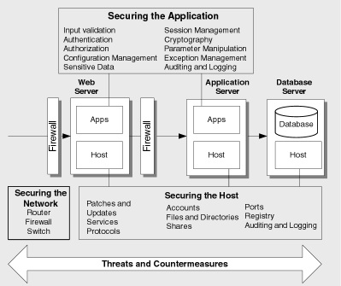
Figure 37: Web Application Security Deployment Scheme

Summary
The report describes the techniques for modeling the “As is” system for the given Bank case study using Class diagram. The logical diagram is then implemented using Oracle Forms. The report later evaluated the developed system with ISO evaluation standards. Finally, the report gives security recommendations for Town’s Bank system and lists the areas that particularly need to be improved and enhanced.
Word Count
2987 Approx

References
[1] J.D. Meier, Alex Mackman, Michael Dunner, Srinath Vasireddy, Ray Escamilla and Anandha Murukan (June 2003) Improving Web Application Security: Threats and Countermeasures.
http://msdn.microsoft.com/en-us/library/ms994921.aspx
Accessed 08 October 2009.
[2] Sumit Jeloka (June 2005) Oracle Database Security Guide 10g Release 2 (10.2) Ch1, 2
[3] Oracle Corporation (June 2008) Oracle Database Security Checklist An Oracle White Paper
[4] Securing Database Servers Database - security for enterprise information systems and security professionals. [Available from:]
http://www.iss.net./prod/whitepapers/securityebus.pdf
[Accessed 9 October 2009]
[5] Sommerville and Ian (2007). Software Engineering (8th ed.) Harlow, England: Pearson Education. ISBN 0-321-31379-8.
[6] Tilson, Roger et al (2000), A Comparison of Two Current E-commerce Sites, ACM.
[7] Adriano B.A & Arnaldo D.B (n.d.) E-Commerce Websites: a Qualitative Evaluation.
[8] Maciaszek, L.A. and Liong, B.L. (2005) Practical Software Engineering. A Case Study Approach, (Ch5). Addison Wesley, Harlow England, ISBN: 0 321 20465 4
[9] Roger S. Pressman (2001) Software Engineering: A Practitioner Approach (2005) Practical Software Engineering. A Case Study Approach, (Ch17,18). McGraw Hill Publication, ISBN: 0 07 365578 3

Appendixes
This section is the complementary section of the report to include the examples of triggers used, queries, test data that have been developed for the case study.
Appendix A – Triggers and Tables Creation
This appendix a list of triggers and tables creation statements in Oracle Forms and Database server developed for the Battle Town’s Bank case study. The list provides only those triggers and table creation statements that are considered relevant in order to describe the overall understanding of the system. For the sake of clarity and avoid the redundant statements some of the triggers and table creation statements have been removed, as the logic behind creation of them is same as described in this appendix.
CASH_DEPOSIT (WHEN-NEW-RECORD-INSTANCE)
/* On form loading initialize some values to fields */
declare
tran_id number;
old_bal number;

begin

select max(trans_id) into tran_id from transaction;
:transaction.trans_id := tran_id + 1;

-- Set the transaction type "3=>cash deposit"
:transaction.trans_type_id_fk := '3';

-- Sets the system date to trans_date field
select SysTimeStamp into :transaction.trans_date from dual;

exception
when NO_DATA_FOUND then
message('No record returned.');
end;
FIELD VALIDATION (WHEN-VALIDATE-ITEM)
--
-- Begin default enforce data integrity constraint SYS_C005556 section
--
if not( :TRANSACTION.TRANS_ID IS NOT NULL ) then
message( 'WHEN-VALIDATE-ITEM trigger failed on field - ' || :system.trigger_field );
raise form_trigger_failure;
end if;
--
-- End default enforce data integrity constraint SYS_C005556 section
--
FIELD VALIDATION (ON-ERROR)
/*
Display error on no input in description field
*/
DECLARE
errnum number := ERROR_CODE; -- ERROR_CODE returns the code of error generated
inputAlert number;
alert_id alert;
BEGIN
IF (errnum = 40202) THEN -- If field is blank
alert_id := Find_Alert('Input_Alert');
Set_Alert_Property('Input_Alert',ALERT_MESSAGE_TEXT,'Enter account id');
inputAlert := Show_Alert('Input_Alert');
END IF;
END;
CASH_DEPOSIT (WHEN-BUTTON-PRESSED)
/*
------------------- CHEQUE DEPOSIT --------------------
When "Save" button is clicked:
1. Validate customer account
2. Update balance
3. Save new transaction
*/

DECLARE
alert_button number;
alert_id alert;
accountId varchar2(20);
lastTransId varchar2(20);
old_bal number;
new_balance number;
record_success_alert number;
input_exception exception;
BEGIN
-- 1. To check whether account entered exists?
select account_id into accountId from account
WHERE account_id = :Transaction.account_id_fk;

-- old balance
select balance into old_bal from account where :Transaction.account_id_fk=accountId;
-- new balance
new_balance := old_bal + :transaction.trans_amount;

-- Save Alert
alert_id := find_alert('Save_Alert');
set_alert_property (alert_id,alert_message_text, 'Do You Want to Save?');
set_alert_property (alert_id,title, 'Confirm');
alert_button := Show_Alert(alert_id);
if alert_button = alert_button2 then -- No
go_item('transaction.account_id_fk');
elsif alert_button = alert_button1 then -- yes
update account set balance = new_balance where account_id=accountId; -- 3. update the balance
commit; -- 4. save changes
clear_block;
record_success_alert := Show_Alert('record_success_alert');
end if;
EXCEPTION
when NO_DATA_FOUND then -- when account does not exist
message('This account number does not exist. Please enter a correct account number');
message(sqlerrm);
WHEN input_exception THEN
record_success_alert := Show_Alert('input_alert');
END;
CASH_DEPOSIT (WHEN-BUTTON-PRESSED)
/* When Cancel button is clicked */
BEGIN
CLEAR_BLOCK(NO_VALIDATE);
CALL_FORM('Assignment2/Menu');
END;
CHEQUE_ DEPOSIT (WHEN-BUTTON-PRESSED)
/*
------------------- CHEQUE DEPOSIT --------------------
When "Save" button is clicked:
1. Validate customer account
2. Update balance
3. Save new transaction
*/

DECLARE
alert_button number;
alert_id alert;
accountId varchar2(20);
lastTransId varchar2(20);
old_bal number;
new_balance number;
record_success_alert number;
input_exception exception;
BEGIN
-- 1. To check whether account entered exists?
select account_id into accountId from account
WHERE account_id = :Transaction.account_id_fk;

-- old balance
select balance into old_bal from account where :Transaction.account_id_fk=accountId;
-- new balance
new_balance := old_bal + :transaction.trans_amount;

-- Save Alert
alert_id := find_alert('Save_Alert');
set_alert_property (alert_id,alert_message_text, 'Do You Want to Save?');
set_alert_property (alert_id,title, 'Confirm');
alert_button := Show_Alert(alert_id);
if alert_button = alert_button2 then -- No
go_item('transaction.account_id_fk');
elsif alert_button = alert_button1 then -- yes
update account set balance = new_balance where account_id=accountId; -- 3. update the balance
commit; -- 4. save changes
clear_block;
record_success_alert := Show_Alert('record_success_alert');
end if;
EXCEPTION
when NO_DATA_FOUND then -- when account does not exist
message('This account number does not exist. Please enter a correct account number');
message(sqlerrm);
WHEN input_exception THEN
record_success_alert := Show_Alert('input_alert');
END;
CASH_WITHDRAWAL (WHEN-BUTTON-PRESSED)
/*
------------------- CASH WITHDRAWAL --------------------
When "Save" button is clicked:
1. Validate customer account
2. Update balance
3. Save new transaction
*/

DECLARE
alert_button number;
alert_id alert;
accountId varchar2(20);
lastTransId varchar2(20);
old_bal number;
new_balance number;
record_success_alert number;
over_alert number;
input_exception exception;
BEGIN
-- 1. To check whether account entered exists?
select account_id into accountId from account
WHERE account_id = :Transaction.account_id_fk;

-- old balance
select balance into old_bal from account where :Transaction.account_id_fk=accountId;
-- new balance
IF ( :transaction.trans_amount > old_bal ) THEN
over_alert := Show_Alert('over_alert');
go_item('trans_amount');
--clear_item;
ELSIF (:transaction.trans_amount <= old_bal ) THEN
new_balance := old_bal - :transaction.trans_amount;
-- Save Alert
alert_id := find_alert('Save_Alert');
set_alert_property (alert_id,alert_message_text, 'Do You Want to Save?');
set_alert_property (alert_id,title, 'Confirm');
alert_button := Show_Alert(alert_id);
if alert_button = alert_button2 then -- No
go_item('transaction.account_id_fk');
elsif alert_button = alert_button1 then -- yes
update account set balance = new_balance where account_id=accountId; -- 3. update the balance
commit; -- 4. save changes
clear_block;
record_success_alert := Show_Alert('record_success_alert');
end if;
END IF;
EXCEPTION
when NO_DATA_FOUND then -- when account does not exist
message('This account number does not exist. Please enter a correct account number');
message(sqlerrm);
WHEN input_exception THEN
record_success_alert := Show_Alert('input_alert');
END;
ACCOUNT TABLE
CREATE TABLE ACCOUNT
( "ACCOUNT_ID" VARCHAR2(20 BYTE) NOT NULL ENABLE,
"BRANCH_SORTCODE_FK" VARCHAR2(20 BYTE) NOT NULL ENABLE,
"ACCOUNT_TYPE_ID_FK" VARCHAR2(20 BYTE) NOT NULL ENABLE,
"STAFF_ID_FK" VARCHAR2(20 BYTE) NOT NULL ENABLE,
"ACCOUNT_NAME" VARCHAR2(20 BYTE) NOT NULL ENABLE,
"DATE_OPENED" DATE,
"DATE_CLOSED" DATE,
"BALANCE" NUMBER,
CONSTRAINT "ACCOUNT_PK" PRIMARY KEY ("ACCOUNT_ID")
USING INDEX PCTFREE 10 INITRANS 2 MAXTRANS 255 COMPUTE STATISTICS
STORAGE(INITIAL 65536 NEXT 1048576 MINEXTENTS 1 MAXEXTENTS 2147483645
PCTINCREASE 0 FREELISTS 1 FREELIST GROUPS 1 BUFFER_POOL DEFAULT)
TABLESPACE "USERS" ENABLE,
CONSTRAINT "ACCOUNT_STAFF_FK1" FOREIGN KEY ("STAFF_ID_FK")
REFERENCES "TESTUSER3"."STAFF" ("STAFF_ID") ENABLE,
CONSTRAINT "ACCOUNT_ACCOUNT_TYPE_FK1" FOREIGN KEY ("ACCOUNT_TYPE_ID_FK")
REFERENCES "TESTUSER3"."ACCOUNT_TYPE" ("ACCOUNT_TYPE_ID") ENABLE
) PCTFREE 10 PCTUSED 40 INITRANS 1 MAXTRANS 255 NOCOMPRESS LOGGING
STORAGE(INITIAL 65536 NEXT 1048576 MINEXTENTS 1 MAXEXTENTS 2147483645
PCTINCREASE 0 FREELISTS 1 FREELIST GROUPS 1 BUFFER_POOL DEFAULT)
TABLESPACE "USERS" ;
ACCOUNT_TYPE TABLE
CREATE TABLE ACCOUNT_TYPE
( "ACCOUNT_TYPE_ID" VARCHAR2(20 BYTE) NOT NULL ENABLE,
"OVERDRAF_LIMIT" NUMBER(5,0),
"OTHER_DETAIL" VARCHAR2(100 BYTE),
"INTEREST_RATE" NUMBER(5,0),
"ACCOUNT_DESC" VARCHAR2(100 BYTE) NOT NULL ENABLE,
CONSTRAINT "ACCOUNT_TYPE_PK" PRIMARY KEY ("ACCOUNT_TYPE_ID")
USING INDEX PCTFREE 10 INITRANS 2 MAXTRANS 255 COMPUTE STATISTICS
STORAGE(INITIAL 65536 NEXT 1048576 MINEXTENTS 1 MAXEXTENTS 2147483645
PCTINCREASE 0 FREELISTS 1 FREELIST GROUPS 1 BUFFER_POOL DEFAULT)
TABLESPACE "USERS" ENABLE
) PCTFREE 10 PCTUSED 40 INITRANS 1 MAXTRANS 255 NOCOMPRESS LOGGING
STORAGE(INITIAL 65536 NEXT 1048576 MINEXTENTS 1 MAXEXTENTS 2147483645
PCTINCREASE 0 FREELISTS 1 FREELIST GROUPS 1 BUFFER_POOL DEFAULT)
TABLESPACE "USERS" ;
MENU (CASH-DEPOSIT trigger)
/*
Call cash_deposit form when button is clicked
*/
BEGIN
call_form('Assignment2/cash_deposit');
END;

Appendix B – Test Cases
The aim of this appendix is to list a possible set of input data with outcome and reasoning behind the outcome of the input. As the transactions developed in the assignment have same interface components (thought the business logic is different), so a single test case can be adequate for all three developed transactions to test and evaluate the developed systems. The table ?? lists the possible set of input data that has been tested to verify the outcome of the system and evaluate it to validate the input data to achieve a highest level of testing at unit level.
Legends: TC1=Transaction ID, TC2=Description, TC3=Amount, TC4=Date
ID | Input | Execution Order | Description  (WHAT IF?) | Outcome  (Pass/Fail) | Reason
TC1 | 1 | 1 | Account exists | P | Account matched
TC1 | 2 | 1 | Account does not exist | F | Account did not matched
TC1 | A | 1 | Non-numeric input is given | F | Invalid account ID
TC1 | & | 1 | Special character input is given | F | Invalid character
TC1 |  | 1 | Blank input is given | F | Field can’t blank
TC1 | 1+1 | 1 | Mathematical input given | F | Invalid input expression
TC2 | 0-9 | 2 | Input is numeric | P
TC2 | a-z | 2 | Input is lowercase character | P
TC2 | A-Z | 2 | Input is uppercase character | P
TC2 | % | 2 | Input is special character | F | Invalid character
TC2 | 2+6 | 2 | Input is algebraic expression | P | Field is character string
TC3 | 0-9 | 3 | Input is numeric | P
TC3 | a-z | 3 | Input is lowercase character | P
TC3 | A-Z | 3 | Input is uppercase character | P
TC3 | % | 3 | Input is special character | F | Invalid character
TC3 | 2+6 | 3 | Input is algebraic expression | P | Field is character string
TC4 | 0-9 | 4 | Input is numeric | F | Invalid date format
TC4 | a-z | 4 | Input is lowercase character | F | Invalid date format
TC4 | A-Z | 4 | Input is uppercase character | F | Invalid date format
TC4 | % | 4 | Input is special character | F | Invalid date format
TC4 | 2+6 | 4 | Input is algebraic expression | F | Invalid date format
TC4 | 3-NOV-2008 | 4 | Input is date (DD-MON-YY) | P | Valid date format
TC4 | 3-11-09 | 4 | Input is date (DD-MM-YY) | P | Valid date format
TC4 | 2009-11-03 | 4 | Input is date (YYYY-MM-DD) | P | Valid date format
TC4 | 25/02/09 | 4 | Input is date (DD/MM/YY) | P | Valid date format
TC4 | 25/07 | 4 | Input is invalid date | F | Invalid date format
Table: Test Case for Cash Deposit, Cheque Deposit and Cash Withdrawal

Appendix C - Running the Developed System
In order to run the developed system, you need some prerequisite software and test script file to load test data. This section describes this process, to successfully run the developed application.
Files, Software and Code Requirements
The following items are required to run the website:
- Oracle Forms 10g
- Source Code for the Assignment (Located inside the given CDROM)
- BattleTownBank.sql file (Located inside the given CDROM)
Configuration Requirements
- Firstly install Oracle database server 9i/10g.
- Open the BattleTownBank.sql with a text editor and copy all contents.
- Open SQLPlus* and paste the contents here.
- New database will be created along with tables and some data inside them.
- Now Go to Oracle Forms 10g and Open the supplied forms (.frm) files.
Running the Program
- Connect to database using your local Oracle password
- Run MENU.frm form which is the main menu for the application.
- Click on required transaction button to perform
Inserting a Transaction
- To insert a new transaction you need to use “1” as ACCOUNT ID as the test script has created only this account in database.
- Input some description of the transaction
- Input the amount. The date will be set automatically from system’s current date/time settings.
- Finally, hit the Save button and you will see the confirmation message.
- Pressing Yes will Save it and message will be displayed on successful transaction.

